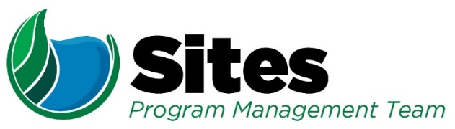
  - Sites Reservoir Project –
  - NEPA Coordination
  - Agenda
Agenda
Date: | October 13, 2020 | Location: | WebEx Link included in Outlook Invitation
Time: | 11:30 AM to 12:30 pm

Leader: | Reclamation/Sites |  | Recorder: | Sites Integration
Purpose: Follow-up to 10/08/2020 USBR Coordination Meeting and Direction to Analyze More Storage
Attendees:
Ryan Davis, Reclamation  Dan Cordova, Reclamation  Melissa Dekar, Reclamation  Daniel Deeds, Reclamation |  | Monique Briard, ICF  Linda Fisher, Sites Integration  Erin Heydinger, Sites Integration |  |  | Laurie Warner Herson, Sites Integration  Nicole Williams, ICF
Agenda:
Discussion Topic |  |  |  |  |  | Topic Leader | Time Allotted
- Introductions – Roll Call and Introductions if new to NEPA call |  |  |  |  |  | Laurie | 2 min
- Project Update  - Reclamation  - Status of the Feasibility Report  - Authority  - Designation of the preferred project –September 17 |  |  |  |  |  | Ryan/Laurie | 10 min
- Confirm Alternative to be analyzed - Our understanding is that Reclamation’s desire is to carry forward either a 1.8 MAF reservoir or be provided a greater share of the storage under the 1.5 MAF alternative.  - How much storage is required to meet Reclamation’s need (“The need is to provide surface water storage north of the Delta that is consistent with WIIN Act requirements and Reclamation Law”)?  - Would Reclamation be able to move forward with the 1.5 MAF reservoir if there is adequate storage available?  - Under the 1.8MAF scenario, can Delevan be eliminated and existing canals be used – has there been any effort to model this? |  |  |  |  |  | Ryan | 20 min
- EIR/EIS Approach - Discuss options for moving forward with the EIS.  - The Authority’s preference is to move forward with the joint EIR/EIS as discussed with Stacey and Richard and we have set up our outline and templates accordingly.  - Assuming we continue with a joint EIR/EIS and Reclamation provides modeling for a larger reservoir and/or greater share of storage, what would the schedule be for modeling?  - Can we meet the summer 2021 release date for a joint document?  - As discussed on Friday, Reclamation is considering preparation of a separate EIS rather than the joint EIR/EIS.  - Would the EIS incorporate by reference the EIR?  - Would Reclamation still participate in review of the EIR and appendices to insure consistency in the analysis?  - What would need to be done by the Authority to support Reclamation’s EIS process?  - What would the modification to the Financial Assistance Agreement look like as the Authority would need additional funding to prepare a separate EIS?  - Whether joint or separate, the Authority is available to support Reclamation in the Cooperating Agency process.  - As the CEQA lead agency, the Authority will need to continue communicate with cooperating agencies outside of the NEPA process. |  |  |  |  |  | Laurie | 20 min
- Next Steps  - Schedule Update  - Revised CEQA Objectives compare to NEPA purpose and need |  |  |  |  |  | All | 3 min

