Draft

Sites Project: Shasta Lake Exchange

Temperature Management Strategies

This document provides a preliminary summary of Sites coordination with Shasta operations to benefit cold water pool management. A comparison of possible Sites and Shasta exchange criteria are tabulated. Then, a summary of Reclamation’s cold water pool management at Shasta, as described in ROC on LTO, is provided. Based on exchange criteria and Shasta cold water pool management, the document concludes with a qualitative assessment of potential Sites benefits to Shasta cold water pool management.

Comparison of Shasta Exchange Criteria
 | Authority Initial Concept – 1 Delevan Pipeline | Reclamation Proposed Criteria | Criteria per ROC on LTO Alternative 1 Description¹ | Notes
Exchange Period | Apr – Jul | Dry: Apr – Jun  Critical: Apr – May | Apr – Jun | According to ROC on LTO ALT1 011519 modeling results, June temperature at CCR is significantly below target in most years. A decrease in Shasta release would not cause temperature at CCR to exceed the temperature threshold.
Exchange Constraints
Water year types | Dry and Critically Dry water years | Dry and Critically Dry water years | Dry and Critically Dry water years
Minimum flow at Sacramento River at Keswick | Apr – May: 6,000 cfs  Jun: 10,000 cfs  Jul: 12,000 cfs | Apr – May: 6,000 cfs | Apr – May: 6,000 cfs  Jun: 10,000 cfs | Exchanges in Dry and Critically Dry water years are not likely to impact ROC on LTO Spring Pulse Flows action
Maximum allowable temperature at Sacramento River below Clear Creek | Apr: No rule  May – Jun: 56 deg F  Jul: 53.5 deg F | Dry:  Apr: 51.2 deg F  May: 51.1 deg F  Jun: 51.5 deg F  Jul: 52.7 deg F  Critical:  Apr: 51.6 deg F  May: 52.2 deg F  Jun: 53.4 deg F  Jul: 55.0 deg F | Apr 1st to May 15th: No rule  May 16th – Jun 30th: 53.5 to 56 deg F (depending on temperature tier) | Per ROC on LTO FEIS
Sacramento Valley Conditions | Only during In Basin Use conditions | Only during In Basin Use conditions | Only during In Basin Use conditions
Release Period | Aug – Nov 15 | Sep – Nov | Aug – Nov | As August is in the hatch period, August releases from Shasta would provide most benefit to Shasta cold water pool management.
Release Constraints
Maximum allowable flow at Sacramento River at Keswick | Aug: 10,000 cfs  Sep: 12,000 cfs | None | Aug: 10,000 cfs  Sep: 12,000 cfs | According to Rice Decomposition Smoothing action, October – November releases must be similar.
Maximum volume | Limited to Banks Pumping Plant Capacity | None | Limited to Banks Pumping Plant Capacity
¹Several assumptions are required to assume exchange operation criteria per ROC on LTO operations. Main assumptions are provided in “Notes” column.

Summary of ROC on LTO Cold Water Pool Management
In the ROC on LTO Alternative 1 description, Reclamation proposes changes to cold water pool management during the temperature management period: May 15th to October 31st or when 95% of Winter-Run Chinook Salmon eggs have hatched and alevin have emerged, whichever is earlier. During the temperature management period, Reclamation will implement a tiered strategy based on Shasta cold water pool or total Shasta storage:
- Tier 1: May 1st cold water pool > 2.8 MAF (total Shasta storage > 4.1 MAF)
  - Daily average temperature of 53.5 deg F at Sacramento River below Clear Creek (CCR) throughout temperature management period
- Tier 2: May 1st cold water pool > 2.3 MAF (total Shasta storage > 3.5 MAF)
  - Daily average temperature of 53.5 deg F at CCR during hatch period (when highest concentration of hatching occurs; estimated as 2 months centered on August 7th)
  - Daily average temperature of 56 deg F at CCR for the rest of the temperature management period (before and after hatch period)
- Tier 3: May 1st total Shasta storage > 2.5 MAF
  - Allow daily average temperature above 53.5 deg F (up to 56 deg F) at CCR during hatch period
  - Attempt to maintain daily average temperature of 56 deg F at CCR for rest of temperature management period (before and after hatch period)
- Tier 4: May 1st total Shasta storage < 2.5 MAF
  - Discuss following intervention measures with USFWS and NMFS:
    - Reclamation would work with USFWS to increase hatchery production of Winter-Run Chinook Salmon
    - Reclamation would implement a downstream trap and haul strategy for the capture and transport of juvenile Chinook Salmon and Steelhead in the Sacramento River watershed.
    - In the event of two successive years with total egg-to-fry survival less than 15% in each year, Reclamation would convene a meeting of the Regional Directors of DWR, NMFS, USFWS, and CDFW to identify and implement actions to address the potential for a third year of low survival.

A decision tree of the tiered strategy is shown on page 12 (Figure 3.4-3 from the ROC on LTO FEIS).

Preliminary Analysis of Shasta Exchange Frequency and Benefits
This section assesses the frequency of potential Shasta exchanges by considering model results from the ROC on LTO FEIS and criteria described in “Criteria per ROC on LTO Alternative 1 Description.” Estimated number of years, flow and temperature conditions, degree of benefit to Winter-Run Chinook Salmon, and limitations to the analysis are detailed below.
Shasta exchange with Sites could occur in Dry and Critical years that are operated to temperature management tiers 2 or 3. Occurrence of years for a given water year type and temperature management tier is displayed in Table 1 (below). Therefore, based on this qualitative analysis, Shasta exchange could benefit cold water pool management in 14 years (highlighted cells in Table 1), or 44% of Dry and Critical years in the planning simulation period.
It should be noted that all ROC on LTO modeling was conducted with future climate conditions (ELT Q5), representative of 2025. Probability of years during which Shasta exchange may benefit water supply and aquatic resource is subject to assumed climate conditions in the modeling.
Table 1: Number of years in a given water year type (WYT) and temperature management tier
WYT | Tier
 | 1 | 2 | 3 | 4
W | 22 | 4 | 0 | 0
AN | 13 | 0 | 0 | 0
BN | 9 | 2 | 0 | 0
D | 12 | 6 | 2 | 0
C | 0 | 2 | 4 | 6

In these 14 years, flow and temperature conditions must be maintained to protect existing water supply and aquatic resources conditions. During the exchange period (April – June), flow at Sacramento below Keswick must remain at or above 6,000 cfs in April and May and 10,000 cfs in June. Furthermore, during the exchange period, daily average temperature at Sacramento River below Clear Creek must remain lower than 56 degrees Fahrenheit in tier 2 and 3 years.
Exceedance plots of Winter-Run Chinook Salmon temperature-based egg mortality in Dry and Critical years are provided at the end of this document (Figures 1-5 and 1-6 from ROC on LTO FEIR Appendix F Attachment 3-8). There is a wide range in temperature-based egg mortality within Dry and Critical years. This range indicates that, during limited storage conditions, mortality is very sensitive to changes in Shasta storage. Small increases to Shasta storage may result in very large reductions of temperature-based egg mortality. As Shasta exchange would only occur in years with limited Shasta storage, incremental storage benefits from Shasta exchange with Sites could reduce temperature-based egg mortality of Winter-Run Chinook Salmon. These reductions in mortality could yield long-term benefits for the Winter-Run Chinook Salmon population.
A preliminary regression analysis of ROC on LTO FEIS Alternative 1 model outputs was conducted to estimate frequency, magnitude and temperature benefits of Shasta exchange. These results do not consider complexities captured in system operations, water temperature, or and mortality models. Additional analysis and modeling will be required to further evaluate benefits of Shasta exchange.
These preliminary calculations estimate that Shasta exchanges are limited to 10 years, or 31% of Dry and Critical years in the planning simulation period. Figure 1 displays an exceedance plot of ROC on LTO annual exchange volumes. Summary tables of exchange volumes and monthly summaries are displayed in Tables 2 through 4. In these tables, number of occurrences, minimum volume, average volume of exchange in years with exchange operations, and maximum exchange volume are provided. Due to flow criteria, exchange volumes are greater in Dry years, when flows are higher. Exchange and release volumes are greatest in May-June and August-September, respectively. These results are similar in frequency and magnitude as compared to results from the initial analyses of Shasta exchange.
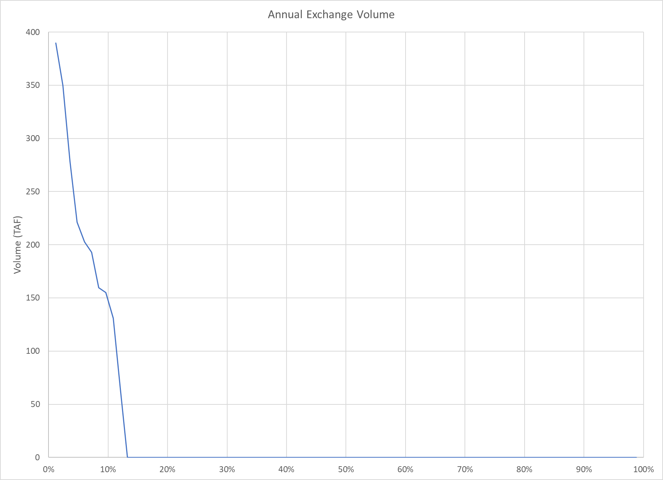
Figure 1: Exceedance Plot of Annual Exchange Volume (TAF)
Table 2: Summary of Exchange by Water Year Type
WYT | Occurrences | Min Volume (TAF) | Avg Volume (TAF) | Max Volume (TAF)
D | 5 | 64 | 247 | 390
C | 5 | 131 | 182 | 221
LT | 10 | 64 | 215 | 390

Table 3: Summary of Exchange Months
Month | Occurrences | Min Volume (TAF) | Avg Volume (TAF) | Max Volume (TAF)
April | 1 | 83 | 83 | 83
May | 9 | 35 | 160 | 315
June | 9 | 7 | 69 | 131

Table 4: Summary of Release Months
Month | Occurrences | Min Volume (TAF) | Avg Volume (TAF) | Max Volume (TAF)
August | 10 | 50 | 109 | 167
September | 9 | 26 | 118 | 299
October | 0 | 0 | 0 | 0
November | 0 | 0 | 0 | 0

All releases occur in August and September, indicating the potential for temperature benefits during the hatch period. Exchanges could, on average, decrease monthly average temperature at Sacramento River below Clear Creek (CCR) by up to 0.4 degrees Fahrenheit in August and September. This decrease in temperature would, on average, reduce temperature-based egg mortality by about 5%. The potential benefits of Shasta exchange on water temperature and egg mortality are displayed in Tables 4 and 5, respectively. Please note that Table 4 presents average temperature data in years with exchange operations.
Table 4: Summary of Temperature Benefits at CCR
Month | Original Temp at CCR (deg F) | Temp Decrease (deg F) | Modified Temp at CCR (deg F)
August | 54.69 | -0.44 | 54.25
September | 56.48 | -0.37 | 56.11

Table 5: Summary of Temperature-based Egg Mortality Benefits
Mortality Model | All Years |  |  | Exchange Years
 | Original Mortality | Modified Mortality | Reduction | Original Mortality | Modified Mortality | Reduction
Martin | 15.15% | 14.55% | 0.60% | 27.32% | 22.42% | 4.90%
Anderson | 13.22% | 12.66% | 0.56% | 23.84% | 19.30% | 4.54%

For context, exchange volumes, by water year type, based on this analysis (ROC on LTO), the Authority’s initial concept and Reclamation’s initial concept are provided in Table 6. Please note that values in this table are averages across all years of a given water year type. Additionally, Figure 2 presents an exceedance plot of annual exchange volumes for the initial concepts. Magnitudes of maximum volume from this analysis and the Authority’s initial concept (Initial Concept – 1 pipe Delevan Pipeline) are similar. Frequency of occurrence from this analysis is similar to the frequency of occurrence of Reclamation’s initial concept (USBR Proposed – 2 pipe Delevan Pipeline). Therefore, annual average exchange volume of ROC on LTO criteria is between the annual average exchange volumes of the Authority’s initial concept and Reclamation’s initial concept.
Table 6: Exchange Volumes for Authority’s Initial Concept, Reclamation’s Initial Concept and ROC on LTO
WYT |  | Authority’s Initial Concept (TAF) | Reclamation’s Initial Concept (TAF) | ROC on LTO (TAF)
W |  | n/a | n/a | n/a
AN |  | n/a | n/a | n/a
BN |  | n/a | n/a | n/a
D |  | 141 | 43 | 62
C |  | 114 | 56 | 76

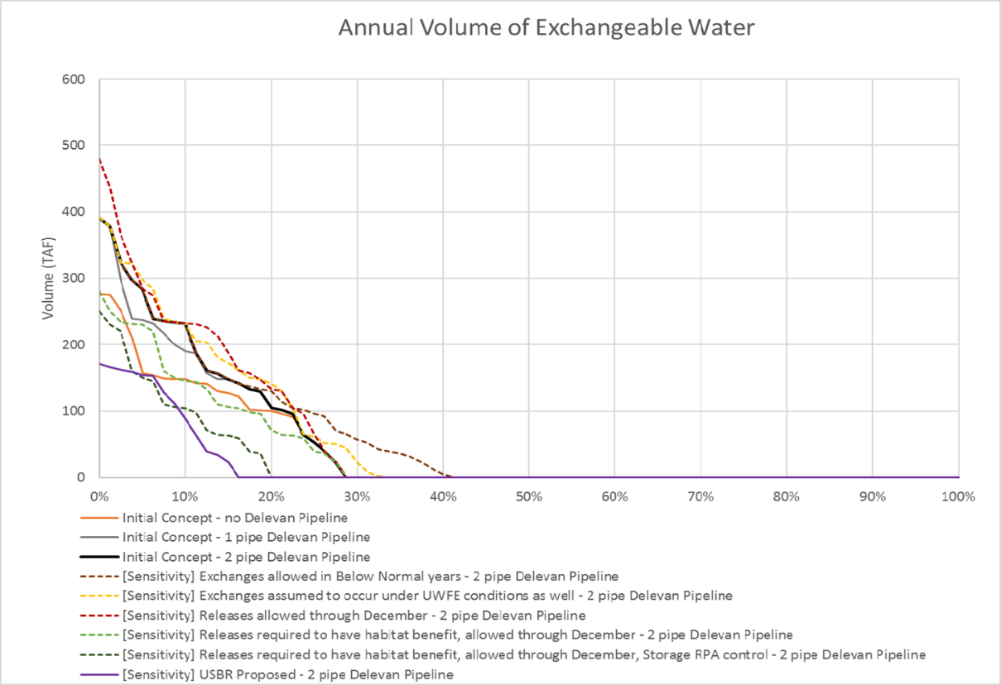
Figure 2: Exceedance Plot of Initial Concept Annual Exchange Volumes
In sum, this analysis demonstrates a potential for Shasta exchange to provide Sacramento River temperature benefits. To more accurately assess temperature benefits from exchanges with Shasta, a series of modeling exercises must be performed. Initially, sensitivity simulations of the HEC5Q, Martin, and Anderson models could be run to assess the potential for temperature and mortality benefits. If sensitivity simulations of temperature and mortality models indicate potential for benefits, exchange operations could be implemented into CalSim II to better understand frequency and volume of exchanges. Then, outputs from CalSim II would be run through temperature and mortality models to quantify temperature and mortality benefits of Shasta exchanges.

Sites Benefits to ROC on LTO Cold Water Pool Management
- Tier 1 years:
  - No benefit
- Tier 2 years:
  - Decreasing releases in April through June could preserve Shasta cold water pool for more targeted release in the hatching period (described above).
- Tier 3 years:
  - Decreasing releases in April through June could preserve Shasta cold water pool for more targeted release in the hatching period (described above).
- Tier 4 years:
  - Little benefit – On its own, Sites could not benefit Shasta cold water pool in an appreciable manner. In combination with intervention measures, Sites may prove beneficial.

Attachments from ROC on LTO FEIS
