Inundated Floodplain and Side-Channel Habitat Analysis, including Yolo and Sutter Bypasses

Introduction
This appendix includes methods and results for quantifying inundated floodplain habitat in the Yolo and Sutter bypasses and inundated side-channel habitat in the Sacramento River for the No Action Alternative (NAA) and Alternatives 1, 2, and 3. Inundated floodplain habitat is created by flows that spill from the Sacramento River into the Yolo Bypass at the Fremont and Sacramento Weirs and into the Sutter Bypass at Ord Ferry and at the Moulton, Colusa, and Tisdale Weirs. Inundated side-channel habitat is created by high flows in the Sacramento River that flood side channels along the main river channel. In addition to estimating acreage of suitable habitat available under the NAA and Alternatives 1, 2, and 3, this appendix provides an analysis of the frequency, duration, and flow of weir spills into the Yolo and Sutter Bypasses. Inundated floodplain and side-channel habitat habitats are important for early life stages of several fish species in the Sacramento River and its tributaries, especially Chinook salmon (Oncorhynchus tshawytscha), steelhead (Oncorhynchus mykiss irideus), and Sacramento splittail (Pogonichthys macrolepidotus). Juvenile Chinook salmon and steelhead use inundated habitat for juvenile rearing, and Sacramento splittail use it for spawning and for larval and juvenile rearing. The analysis of weir spills provides information on the possibility of fish entering the bypasses via weir spills, which is an important avenue by which juvenile salmonid access the bypasses (Acierto et al. 2014). Because of their regulatory importance and their heavy reliance on inundated off-channel habitat, this appendix focuses on the three species listed above.

Methods

Bypass and Side-Channel Inundated Habitat Area
This analysis examines the surface area of suitable inundated floodplain and side-channel habitat that would be available under the NAA and Alternatives 1, 2, and 3. Inundated habitat with depths up to 1 meter, which correspond to optimal depths for rearing salmonids and steelhead in the Sacramento River drainage, was considered suitable for salmonids and Sacramento splittail (Aceituno 1990; Hampton 1997; Sommer et al. 2002; U.S. Fish and Wildlife Service 2005; Whipple et al. 2019). Flow velocity was not explicitly modeled because previous modeling showed that almost all inundated habitat in the bypasses has flows less than 1.5 feet per second (Sommer et al. 2001a), which is optimal for rearing salmonids (U.S. Fish and Wildlife Service 2005; Whipple et al. 2009).
Daily estimates of the surface area of suitable inundated habitat were generated from HEC-RAS model runs using daily flow data (Upper Sacramento River Daily Operations Model [USRDOM]) for the NAA and Alternatives 1, 2, and 3. Yolo Bypass habitat area was estimated from flow spills at the Fremont and Sacramento Weirs, plus monthly westside stream flows disaggregated into daily flows using the historical flow patterns. Sutter Bypass habitat area was estimated using flows entering the Sutter Bypass from the Sacramento River at Ord Ferry and the Moulton, Colusa, and Tisdale Weirs. Inundated side-channel habitat was estimated for three reaches of the upper Sacramento River: Reach 1 – Bend Bridge to Hamilton City; Reach 2 – Hamilton City to Colusa; and Reach 3 – Colusa to Knights Landing. The Reach 1 flow was computed as the flow at Bend Bridge minus the diversion flows at Red Bluff and Hamilton City. The Reach 2 and Reach 3 flows are the flows at Hamilton City and Colusa, respectively. Flow versus habitat area curves were developed from the HEC-RAS modeling results (Figure 11M-1 through Figure 11M-5). The HEC-RAS modeling of habitat inundation area uses steady state-like flow conditions lasting 8 days or more. As a result, daily inundation areas were calculated based on the 8-day running averages of flow throughout the 82-year simulated flow data record, excluding the first 8 days. Note that suitable habitat plateaus in the Yolo Bypass at flows between about 4,000 cubic feet per second (cfs) and 11,000 cfs and in the Sutter Bypass at flows between 1,000 cfs and 3,000 cfs. Higher flows reduce the acreage of suitable habitat as the area of inundation with depth less than 1 meter declines. Note also that HEC-RAS model was focused on high flow conditions to evaluate flow over Fremont Weir and was not tailored to low-flow conditions.

Figure 11M-1. Yolo Bypass Suitable (<1 Meter Deep) Habitat Acreage versus Total Bypass Flow.

Figure 11M-2. Sutter Bypass Suitable (< 1 Meter Deep) Habitat Acreage versus Total Bypass Flow.

Figure 11M-3. Sacramento River Reach 1 (Bend Bridge to Hamilton City) Side-Channel Suitable (< 1 Meter Deep) Habitat Acreage versus Bend Bridge Flow (minus Red Bluff and Hamilton City Diversions).

Figure 11M-4. Sacramento River Reach 2 (Hamilton City to Colusa) Side-Channel Suitable (< 1 Meter Deep) Habitat Acreage versus Hamilton City Flow.

Figure 11M-5. Sacramento River Reach 3 (Colusa to Knights Landing) Side-Channel Suitable (< 1 Meter Deep) Habitat Acreage versus Colusa Flow.
In addition to the estimates of daily habitat acreage, frequencies of inundation events of different acreages and durations were estimated for the NAA and Alternatives 1, 2, and 3. For durations, the events were grouped into ranges: 8–17 days; 18–24 days; and over 24 days. For acreages, the events were grouped into different ranges for the three different regions (Yolo Bypass, Sutter Bypass, and Sacramento River side-channels) analyzed, with the Yolo Bypass having categories with the largest acreages and the Sacramento River having categories with the smallest acreages.

Bypass Flow and Weir Spill
As discussed in the introduction, most juvenile salmonids likely enter the bypasses via weir spills (Acierto et al. 2014). The frequency, duration, and volume of the spills characterize the frequency and size of juvenile salmonid movements into the bypasses via the weir spills. Note, however, that the total flow in the bypass is not always a good indicator of suitable habitat availability, as shown in Figures 11M-1 and 11M-2.

Yolo Bypass
The number of years in the 82-year simulation period with at least one Fremont Weir spill event of varying sizes (0; 2,000; 4,000; 6,000; 8,000; and 10,000 cfs) with a duration of 0–10 days, 11–20 days, 21–30 days, 31–45 days, and over 45 days are calculated from the daily flow results. This analysis was limited to the October through April period in which juvenile salmonids and spawning splittail could be present in the Yolo Bypass.
Daily total Yolo Bypass flow results used in the current analysis were estimated using the daily CALSIM II outputs of flow spills at Fremont and Sacramento Weirs, and monthly west-side stream flows disaggregated into daily flows using the historical flow patterns.
Daily Fremont Weir spill output from CalSim II was used in this analysis. Daily outputs from CalSim II were based on a monthly-to-daily flow mapping technique applied in the model for a better representation of flows and spills along the Sacramento River between Red Bluff and Freeport. More information regarding CalSim II’s incorporation of daily variability is included in Appendix 5A7, Daily Pattern Development for the Estimation of Daily Flows and Weir Spills in CalSim II.

Sutter Bypass
Similar to the methodology used for the Yolo Bypass, modeled daily spill into the Sutter Bypass from the Sacramento River at Ord Ferry and the Moulton, Colusa, and Tisdale Weirs was used to examine the frequency, duration, and flow of total spill into the Sutter Bypass that could provide rearing habitat for salmonids and splittail. Spill (flow) at Ord Ferry, Moulton Weir, and Colusa Weir were combined to assess potential changes in the northern portion of the Sutter Bypass; total spill at Ord Ferry and the Moulton, Colusa, and Tisdale Weirs was combined to assess potential impacts in the central portion of the bypass; and total flow through the bypass was used as an indicator of potential changes in floodplain habitat in the southern portion of the bypass. The number of years where there is at least one event of spill over the weirs into the Sutter Bypass of varying amounts (0; 2,000; 4,000; 6,000; 8,000; and 10,000 cfs) with a duration of 0–10 days, 11–20 days, 21–30 days, 31–45 days, and greater than 45 days was calculated from the daily results. This analysis was limited to the October through April period in which juvenile salmonids are anticipated to enter the Sutter Bypass.

Results

Yolo Bypass Weir Spill Events and Inundated Floodplain Habitat Area
Results for Yolo Bypass Fremont Weir spill events are provided in Attachment 1, Table 1. The results suggest that Alternatives 1, 2, and 3 would have fewer days of Fremont Weir spill than the NAA, especially for the shorter duration flows (less than 20 days). Opportunities for juvenile salmonids to enter the Yolo Bypass for rearing are therefore somewhat reduced under Alternatives 1, 2, and 3 relative to the NAA.
Takata et al. (2017) examined various juvenile Chinook salmon biological responses to Yolo Bypass flooding, which they defined as the number of days from January through June with daily mean flows at the downstream end of Yolo Bypass greater than 4,000 cfs; this is the flow at which floodplain inundation occurs. Takata et al. (2017) found that growth and floodplain residence of coded-wire-tagged juvenile Chinook salmon and catch per unit effort of wild juvenile Chinook salmon are significantly positively related to the annual duration of Yolo Bypass flooding (Takata et al. 2017: Figures 3 and 4c). Daily-downscaled CALSIM modeling suggests that operations under Alternatives 1, 2, and 3 may reduce Yolo Bypass inundation from January through June by approximately 1 day across most water year types (Table 11M-1). Given the variability in the observed biological relationships indicated by the spread in the data (Takata et al. 2017: Figures 3 and 4c), and no significant difference in survival to capture in ocean fisheries between coded-wire-tagged juvenile Chinook salmon released in the Yolo Bypass and those released at the same time in the Sacramento River (Takata et al. 2017), the small differences in Yolo Bypass inundation indicated by the CALSIM modeling suggest that Alternatives 1, 2, and 3 are limited in their potential for negative effects on juvenile Chinook salmon, including winter-run.
Table 11M-1. Mean Annual Number of Days in January–June With Yolo Bypass Floodplain Inundation by Alternative and Water Year Type.
Water Year Type | NAA | Alt 1A | Alt 1B | Alt 2 | Alt 3
Wet | 71 | 70 (-2%) | 70 (-2%) | 70 (-2%) | 70 (-2%)
Above Normal | 52 | 51 (-2%) | 51 (-2%) | 51 (-2%) | 52 (-1%)
Below Normal | 19 | 18 (-4%) | 18 (-4%) | 18 (-4%) | 18 (-4%)
Dry | 8 | 7 (-7%) | 7 (-7%) | 7 (-7%) | 7 (-7%)
Critically Dry | 4 | 4 (-2%) | 4 (-2%) | 4 (-2%) | 4 (-2%)
Note: Percentage values in parentheses indicate differences of alternatives compared to NAA. Floodplain inundation is Yolo Bypass flow >4,000 cfs per Takata et al. (2017).

The modeling results of Yolo Bypass inundated suitable habitat show considerable increases in mean daily habitat acreage under Alternatives 1, 2, and 3 relative to the NAA during August through October (Table 11M-2). Note, however, that these increases may be overestimated because the HEC-RAS model used for the inundation evaluation was focused on high flow conditions to evaluate flow over Fremont Weir and was not tailored to summer, low-flow conditions. These increases are the result of planned agricultural flow releases from Sites Reservoir. The releases reach the Yolo Bypass via the CBD, entirely bypassing the Sacramento River. For this reason and because of the months in which they occur, these summer–fall increases in habitat acreage have no effect on most of the fish species of management concern that use the Yolo Bypass for spawning and rearing habitat in the winter and spring. Note that for convenience in locating results of the Alternatives 1, 2, and 3 with the largest differences from the NAA, results with >5% increases or reductions in habitat area are flagged with green or red highlighting, respectively. This convention is used in all the results tables below (Table 11M-2 through Table 11M-5).
For January through July, the model results range from no change to moderate reductions in Yolo Bypass mean daily habitat acreage under Alternatives 1, 2, and 3 (Table 11M-2). The results for November and December range from moderate reductions to moderate increases in habitat. Note that while the increases during late summer and fall are, on a percentage basis, consistently much larger than the reductions in winter, spring, and early summer, in terms of absolute differences in acreage, some of the winter and spring reductions are larger than some of the summer and fall increases (Table 11M-2). For instance, the reductions in acreage from the NAA to Alternatives 1, 2, and 3 for March of Below Normal Water Years are larger than some of the summer and fall increases. The largest reductions under Alternatives 1, 2, and 3 occur for March of Below Normal and Dry Water Years and April of Below Normal Water Years, ranging from about 6% to 11% below the NAA acreages. In terms of mean daily acreage, the differences range from 175 acres to 418 acres. The only other relatively large reductions are 17% (183 acres) and 13% (137 acres) reductions in November of Above Normal Water Years under Alternatives 2 and 3. The reductions in July are moderately large on a percentage basis but are small in terms of acreage, with all July reductions being less than 12 acres. Other mean daily acreage reductions in winter and spring are minor but numerous; they occur for most of the months and water year types under all Alternatives 1, 2, and 3 (Table 11M-2).

Table 11M-2. Estimated Mean Daily Inundated Habitat (Acres <1 Meter Deep) for Juvenile Salmonids in the Yolo Bypass and the Percent Differences (in parentheses) for the No Action Alternative (NAA) and Alternatives 1–3 (Alt 1A, Alt 1B, Alt 2, and Alt 3).
Month | Water Year Type | NAA | Alt 1A | Alt 1B | Alt 2 | Alt 3
January | Wet | 14,250 | 14,169 (-0.6%) | 14,169 (-0.6%) | 14,189 (-0.4%) | 14,172 (-0.5%)
 | Above Normal | 11,853 | 11,777 (-0.6%) | 11,778 (-0.6%) | 11,778 (-0.6%) | 11,774 (-0.7%)
 | Below Normal | 6,202 | 6,078 (-2%) | 6,084 (-1.9%) | 6,082 (-1.9%) | 6,089 (-1.8%)
 | Dry | 1,758 | 17,16 (-2.4%) | 1,707 (-2.9%) | 1,716 (-2.4%) | 1,725 (-1.9%)
 | Critically Dry | 1,533 | 1,500 (-2.1%) | 1,500 (-2.1%) | 1,500 (-2.2%) | 1,500 (-2.1%)
 | All | 7,922 | 7,850 (-0.9%) | 7,849 (-0.9%) | 7,857 (-0.8%) | 7,855 (-0.9%)
February | Wet | 17,195 | 17,182 (-0.1%) | 17,183 (-0.1%) | 17,181 (-0.1%) | 17,176 (-0.1%)
 | Above Normal | 16,646 | 16,537 (-0.7%) | 16,567 (-0.5%) | 16,549 (-0.6%) | 16,634 (-0.1%)
 | Below Normal | 10,559 | 10,403 (-1.5%) | 10,417 (-1.4%) | 10,408 (-1.4%) | 10,436 (-1.2%)
 | Dry | 4,730 | 4,564 (-3.5%) | 4,584 (-3.1%) | 4,564 (-3.5%) | 4,582 (-3.1%)
 | Critically Dry | 1,424 | 1,393 (-2.1%) | 1,393 (-2.1%) | 1,393 (-2.1%) | 1,394 (-2.1%)
 | All | 10,930 | 10,843 (-0.8%) | 10,854 (-0.7%) | 10,845 (-0.8%) | 10,865 (-0.6%)
March | Wet | 14,644 | 14,562 (-0.6%) | 14,559 (-0.6%) | 14,561 (-0.6%) | 14,547 (-0.7%)
 | Above Normal | 12,983 | 12,750 (-1.8%) | 12,771 (-1.6%) | 12,751 (-1.8%) | 12,767 (-1.7%)
 | Below Normal | 5,387 | 4,968 (-7.8%)^ | 4,982 (-7.5%)^ | 4,972 (-7.7%)^ | 5,003 (-7.1%)^
 | Dry | 3,906 | 3,631 (-7%)^ | 3,634 (-7%)^ | 3,634 (-7%)^ | 3,656 (-6.4%)^
 | Critically Dry | 1,362 | 1,306 (-4.2%) | 1,305 (-4.2%) | 1,305 (-4.2%) | 1,308 (-4%)
 | All | 8,520 | 8,319 (-2.4%) | 8,324 (-2.3%) | 8,320 (-2.3%) | 8,329 (-2.2%)
April | Wet | 11,327 | 11,173 (-1.4%) | 11,164 (-1.4%) | 11,185 (-1.3%) | 11,158 (-1.5%)
 | Above Normal | 5,434 | 5,442 (0.2%) | 5,442 (0.2%) | 5,442 (0.2%) | 5,442 (0.2%)
 | Below Normal | 1,603 | 1,428 (-10.9%)^ | 1,428 (-10.9%)^ | 1,428 (-10.9%)^ | 1,428 (-10.9%)^
 | Dry | 1,205 | 1,202 (-0.2%) | 1,202 (-0.2%) | 1,202 (-0.2%) | 1,204 (-0.1%)
 | Critically Dry | 520 | 520 (0%) | 520 (0%) | 520 (0%) | 520 (0%)
 | All | 5,001 | 4,923 (-1.6%) | 4,920 (-1.6%) | 4,927 (-1.5%) | 4,918 (-1.7%)
May | Wet | 2,776 | 2,647 (-4.6%) | 2,643 (-4.8%) | 2,647 (-4.6%) | 2,611 (-5.9%)^
 | Above Normal | 1,548 | 1,543 (-0.3%) | 1,543 (-0.3%) | 1,543 (-0.3%) | 1,543 (-0.3%)
 | Below Normal | 455 | 455 (0%) | 455 (0%) | 455 (0%) | 455 (0%)
 | Dry | 267 | 267 (0%) | 267 (0%) | 267 (0%) | 267 (0%)
 | Critically Dry | 168 | 168 (0%) | 168 (0%) | 168 (0%) | 168 (0%)
 | All | 1,267 | 1,226 (-3.3%) | 1,225 (-3.4%) | 1,226 (-3.3%) | 1,215 (-4.2%)
June | Wet | 856 | 827 (-3.3%) | 827 (-3.3%) | 827 (-3.3%) | 828 (-3.3%)
 | Above Normal | 166 | 166 (0%) | 166 (0%) | 166 (0%) | 166 (0%)
 | Below Normal | 160 | 160 (0%) | 160 (0%) | 160 (0%) | 160 (0%)
 | Dry | 164 | 164 (0%) | 164 (0%) | 164 (0%) | 164 (0%)
 | Critically Dry | 155 | 155 (0%) | 155 (0%) | 155 (0%) | 155 (0%)
 | All | 382 | 373 (-2.4%) | 373 (-2.4%) | 373 (-2.3%) | 373 (-2.3%)
July | Wet | 121 | 110 (-9.8%)^ | 110 (-9.8%)^ | 110 (-9.8%)^ | 110 (-9.8%)^
 | Above Normal | 112 | 100 (-10.3%)^ | 100 (-10.1%)^ | 100 (-10.7%)^ | 101 (-9.5%)^
 | Below Normal | 108 | 101 (-6.6%)^ | 101 (-6.3%)^ | 99 (-8.6%)^ | 101 (-6.3%)^
 | Dry | 114 | 107 (-6.2%) | 107 (-6.6%) | 106 (-7.6%) | 108 (-5.7%)
 | Critically Dry | 117 | 113 (-3.4%) | 114 (-2.7%) | 113 (-4.1%) | 116 (-1.1%)
 | All | 116 | 107 (-7.6%)^ | 107 (-7.5%)^ | 106 (-8.4%)^ | 107 (-7%)^
August | Wet | 309 | 958 (210.3%)* | 958 (210.2%)* | 956 (209.8%)* | 959 (210.6%)*
 | Above Normal | 195 | 800 (309.7%)* | 792 (305.3%)* | 835 (327.3%)* | 750 (283.9%)*
 | Below Normal | 253 | 679 (167.9%)* | 680 (168.3%)* | 799 (215.2%)* | 679 (168%)*
 | Dry | 142 | 546 (285.1%)* | 583 (310.7%)* | 636 (348.6%)* | 517 (264.5%)*
 | Critically Dry | 127 | 348 (175.1%)* | 298 (135.8%)* | 399 (215.1%)* | 196 (54.7%)*
 | All | 219 | 708 (222.5%)* | 707 (222.3%)* | 760 (246.3%)* | 672 (206.2%)*
September | Wet | 204 | 957 (368.7%)* | 941 (360.6%)* | 1,020 (399.3%)* | 924 (352.2%)*
 | Above Normal | 165 | 890 (439.7%)* | 757 (358.7%)* | 895 (442.6%)* | 831 (403.9%)*
 | Below Normal | 281 | 620 (120.3%)* | 581 (106.5%)* | 734 (160.8%)* | 605 (115.2%)*
 | Dry | 161 | 610 (279.9%)* | 540 (236%)* | 568 (253.9%)* | 416 (158.8%)*
 | Critically Dry | 181 | 322 (78.4%)* | 345 (91.1%)* | 283 (56.6%)* | 261 (44.3%)*
 | All | 199 | 721 (262.9%)* | 677 (241%)* | 746 (275.5%)* | 647 (225.9%)*
October | Wet | 375 | 889 (137%)* | 794 (111.7%)* | 848 (126.1%)* | 792 (111.2%)*
 | Above Normal | 101 | 368 (262.6%)* | 360 (255.2%)* | 434 (327.9%)* | 391 (284.9%)*
 | Below Normal | 104 | 460 (341.6%)* | 445 (326.7%)* | 494 (374.4%)* | 375 (259.6%)*
 | Dry | 319 | 735 (130.9%)* | 717 (125.2%)* | 729 (128.9%)* | 557 (75%)*
 | Critically Dry | 106 | 272 (157.3%)* | 202 (91.1%)* | 316 (198.9%)* | 200 (89.2%)*
 | All | 237 | 616 (159.6%)* | 568 (139.3%)* | 624 (162.8%)* | 524 (120.9%)*
November | Wet | 2,174 | 2,217 (2%) | 2,241 (3.1%) | 2,212 (1.8%) | 2238 (3%)
 | Above Normal | 1,073 | 1,093 (1.8%) | 1,104 (2.9%) | 890 (-17.1%)^ | 936 (-12.8%)^
 | Below Normal | 111 | 141 (26.8%)* | 145 (30.3%)* | 142 (27.7%)* | 135 (21.3%)*
 | Dry | 614 | 641 (4.4%) | 640 (4.4%) | 640 (4.4%) | 622 (1.3%)
 | Critically Dry | 54 | 65 (20.8%)* | 72 (32.3%)* | 70 (28.9%)* | 59 (8.1%)*
 | All | 1,008 | 1,037 (2.9%) | 1,048 (4%) | 1,007 (-0.1%) | 1,015 (0.7%)
December | Wet | 11,276 | 11,280 (0%) | 11,293 (0.1%) | 11,287 (0.1%) | 11,389 (1%)
 | Above Normal | 3,571 | 3,553 (-0.5%) | 3,552 (-0.5%) | 3,538 (-0.9%) | 3,508 (-1.8%)
 | Below Normal | 1,801 | 1,780 (-1.2%) | 1,781 (-1.1%) | 1,780 (-1.2%) | 1,783 (-1%)
 | Dry | 1,607 | 1,610 (0.2%) | 1,667 (3.8%) | 1,617 (0.6%) | 2,120 (31.9%)*
 | Critically Dry | 234 | 240 (2.4%) | 241 (2.7%) | 240 (2.3%) | 240 (2.5%)
 | All | 4,792 | 4,789 (-0.1%) | 4,806 (0.3%) | 4,790 (0%) | 4,929 (2.9%)
* Results for which habitat acreage under Alternative 1, 2, or 3 is more than 5% below habitat acreage under the NAA are highlighted green.
^ Results for which habitat acreage under Alternative 1, 2, or 3 is more than 10% higher than habitat acreage under the NAA are highlighted red.

The differences between the NAA and Alternatives 1, 2, and 3 in Yolo Bypass habitat availability were also examined by plotting probabilities of exceedance of all the daily habitat acreages for the months of January through April combined (Figure 11M-6). The exceedance curves show a consistent but small reduction in habitat acreages under Alternatives 1, 2, and 3 relative to the NAA from about the 40% to 20% exceedances. There are no appreciable differences between the NAA and Alternatives 1, 2, and 3 for the uppermost and lowermost acreages. Figure 11M-6 provides only a portion of the full exceedance plot (i.e., 2,000 acres to 20,000 acres) to make differences more visible.
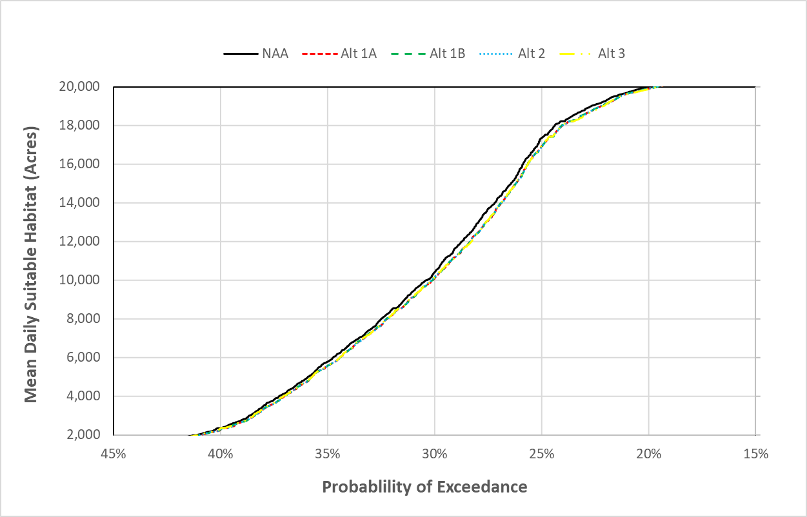
Figure 11M-6. Portions of Exceedance Curves for January through April Daily Yolo Bypass Suitable Habitat Acreage between for the No Action Alternative (NAA) and Alternatives 1–3 (Alt 1A, Alt 1B, Alt 2, and Alt 3).
A further analysis was carried out to examine the net effect of all the January through April changes between the NAA and Alternatives 1, 2, and 3 in daily habitat acreage. For this analysis, means were computed for all daily habitat acreages from January through April for all years (Table 11M-3). The average difference is a reduction of 107 acres, or about 1.3% of the NAA acreage.
Table 11M-3. Estimated Mean Daily January through April Inundated Habitat (Acres <1 Meter Deep) for Juvenile Salmonids in the Yolo Bypass and the Differences (in parentheses) for the No Action Alternative (NAA) and Alternatives 1–3 (Alt 1A, Alt 1B, Alt 2, and Alt 3).
NAA | Alt 1A | Alt 1A | Alt 1A | Alt 1A
8,053 | 7,942 (-110) | 7,945 (-107) | 7,946 (-107) | 7,950 (-103)

It should be noted that the modeling results slightly overestimate some reductions in the winter and spring suitable habitat acreage between the NAA and Alternatives 1, 2, and 3. This occurs because 21,200 cfs is an upper boundary condition of the habitat model and all higher flows are assigned a constant habitat acreage value of 18,043 acres (see Figure 11M-1). However, flows greater than 21,200 cfs are generally somewhat higher under the NAA than Alternatives 1, 2, and 3 because of diversions by Alternatives 1, 2, and 3 to the Sites Reservoir (Figure 11M-7). Figure 11M-7 provides only a small portion of the full exceedance plot (i.e., 210,000 cfs to 340,000 cfs) to make differences more visible. Suitable inundated habitat on the Yolo Bypass declines with flow at flows above about 11,000 cfs (Figure 11M-1) and continues to do so at flows well above 21,200 cfs (Cordoleani et al. 2020: Appendix B). Therefore, habitat acreage at flows above 21,200 cfs, which the model sets at 18,043 acres for the NAA and Alternatives 1, 2, and 3, are actually larger for Alternatives 1, 2, and 3 than for the NAA, which means that the model slightly underestimates habitat acreage of Alternatives 1, 2, and 3 relative to the NAA for all means that include flows greater than 21,200 cfs.
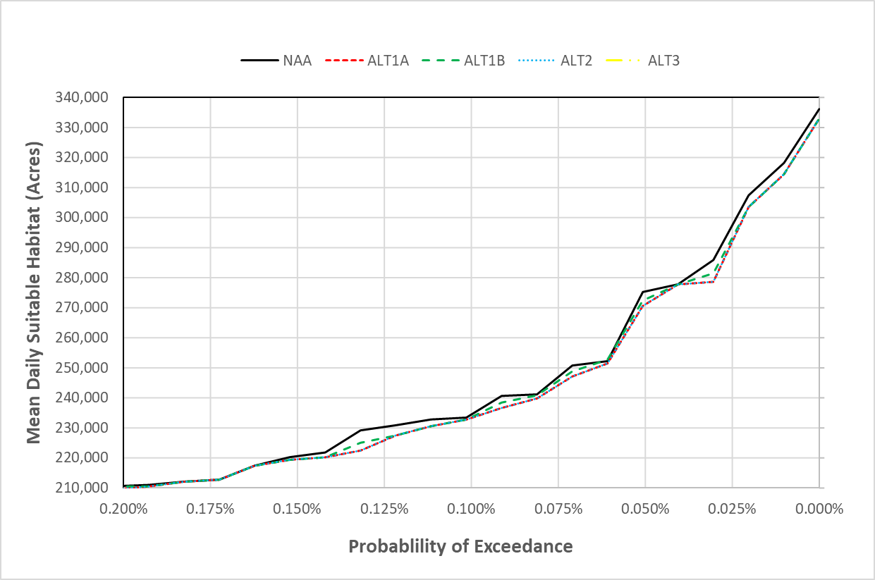
Figure 11M-7. Portions of Exceedance Curves for January through April Daily Yolo Bypass Flow for the No Action Alternative (NAA) and Alternatives 1–3 (Alt 1A, Alt 1B, Alt 2, and Alt 3).
The fish species of management concern most likely to be affected by the changes in Yolo Bypass inundated suitable habitat are Chinook salmon, steelhead, and Sacramento splittail. Recent studies have demonstrated that, when inundated by high flows in the winter and spring, the Yolo Bypass provides good rearing habitat for juvenile salmonids (Sommer et al. 2001b; Sommer et al. 2005; Hinkleman et al. 2017; Katz et al. 2017; Bellido-Leiva et al. 2021). Additionally, the Yolo Bypass is the most important spawning, nursery, and juvenile rearing habitat for Sacramento splittail (Sommer et al. 2001a, Sommer et al. 2002; Moyle et al. 2004; Feyrer et al. 2006a; Feyrer et al 2006b; Sommer et al. 2008). These species use the Yolo Bypass during the winter and spring, the natural period for seasonal floodplain inundation in the Sacramento River Basin. By late summer and fall, when Alternatives 1, 2, and 3 are expected to result in the largest percentage increases in Yolo Bypass suitable habitat (Table 11M-2), rearing salmonids and Sacramento splittail have emigrated from the bypass, except for those trapped in pools (Sommer et al. 2005). Most of the fish species remaining in the bypass after mid-summer are nonnative species, including black bass (Micropterus spp.) and striped bass (Morone saxatilis), which are fish species (or species groups) of management concern (Sommer et al. 2001a; Sommer et al. 2004).
Salmon and steelhead juveniles are most likely to enter the Yolo Bypass while rearing in and emigrating from the lower Sacramento River. California Department of Water Resources has a Rotary Screw Trap (RST) at Knights Landing that is 11 kilometers upstream of Fremont Weir and provides the most reliable information on when the juveniles are most likely to access the Yolo Bypass, assuming the Fremont Weir is spilling. Most of the catch of juvenile salmon and steelhead at Knights Landing occurs during October through May (Attachment 1 of Appendix 11A). Significant spilling of the Fremont Weir generally begins in November or December and may occur as late as May. One race or another of juvenile Chinook salmon or steelhead is likely to enter the Yolo Bypass during most of this period. Based on the Knights Landing RST data, the presence of the different races and species of juvenile salmon and steelhead near the Fremont Weir generally occurs as follows: winter-run from October through March, spring-run from December through April, fall run from January through April, late fall–run from April through January, and steelhead from January through May. Once on the Yolo Bypass, the juveniles may remain for a month or more, depending on conditions (Sommer et al. 2005). On this basis, the March and April reductions in suitable habitat expected to result from Alternatives 1, 2, and 3 would potentially affect rearing juveniles of all four salmon races and steelhead. As noted above, the largest difference in mean acreages for March and April was 419 acres. The reductions in January and February are small but consistent, which could result in a cumulative effect (Table 11M-2). The exceedance curves also show small but consistent reductions under Alternatives 1, 2, and 3 (Figure 11M-6). However, when the net effect of all daily differences between the NAA and Alternatives 1, 2, and 3 are examined, the differences are small (Table 11M-3) and the effect on the Chinook salmon and steelhead populations is expected to be minor. .
Of the three fish species of management concern, Sacramento splittail likely benefits most from inundated floodplain habitat (Sommer et al. 2001a, Feyrer et al. 2005). Adult splittail begin their upstream spawning migrations from the Delta during winter and spring and spawn on the Yolo Bypass from late winter to late spring in years when the bypass is inundated. Timing of spawning depends on the timing of inundation, but most often peaks during March (Feyrer et al. 2006a). Egg incubation and larval development require a few weeks to a month, depending on water temperature (Moyle et al. 2004). The juveniles rear in the bypass for as long as conditions are suitable and typically return to the Delta from April through July (Feyrer et al. 2005),
Splittail benefit from Yolo Bypass inundation primarily during the spawning and rearing periods, which typically run from February through April or May. This period largely overlaps the timing of the greatest and most consistent habitat reductions associated with Alternatives 1, 2, and 3 (Table 11M-2). However, as noted above, the net effect of all daily differences between the NAA and Alternatives 1, 2, and 3 are small reductions in habitat acreage (Table 11M-3). Therefore, the habitat reductions are not expected to have a substantial negative effect on the Sacramento splittail population.
As noted in the Section 2, Methods, in addition to evaluating effects of Alternatives 1, 2, and 3 on mean daily habitat acreage, this report also examines effects of Alternatives 1, 2, and 3 on the frequency, duration and acreage of inundation events. This analysis is important because the value of inundated habitat varies with its duration and total acreage, and the value may be species-specific. For instance, the productivity of inundated floodplain habitat for juvenile salmonids is maximized after about 18 days of inundation and begins to diminish by about 24 days (Whipple et al. 2019). In contrast, Sacramento splittail require at least 30 days of inundation for completion of spawning, egg incubation, and larval development, after which the juveniles are large and strong enough to emigrate more safely from the floodplain (Feyrer et al. 2006a).
The results of the frequency analysis of inundation of events for the Yolo Bypass generally show only minor difference between Alternatives 1, 2, and 3 and the NAA (Figure 11M-7). However, there are moderate increases in frequency for Alternatives 1, 2, and 3 compared to the NAA for events of 2,500 to 15,000-acre lasting 8 to 17 days, with frequencies ranging from once per 1.8 years for Alternative 1B to once per 2.2 years for the NAA. There are minor reductions for Alternatives 1, 2, and 3 for the same acreage range lasting 18–24 days, with frequencies ranging from once per 17 years for the NAA to once per 25 years for Alternatives 1B and 3. There are also minor increases in frequency for events greater than 20,000 acres lasting 18–24 days for all Alternatives 1, 2, and 3 except Alternative 3. Note that the greater frequency of the large acreage inundation events under Alternatives 1, 2, and 3 likely results from the moderately lower frequency of high flows under Alternatives 1, 2, and 3 because of diversions to Sites Reservoir and the fact that suitable inundated habitat declines with flow at flows above about 11,000 cfs (Figure 11M-1). The differences in frequencies of inundation events of varying duration and acreage show no consistent differences between the NAA and Alternatives 1, 2, and 3. Tables providing the results plotted in Figure 11M-8 and frequency of inundation tables for every month are provided in Attachment 3.

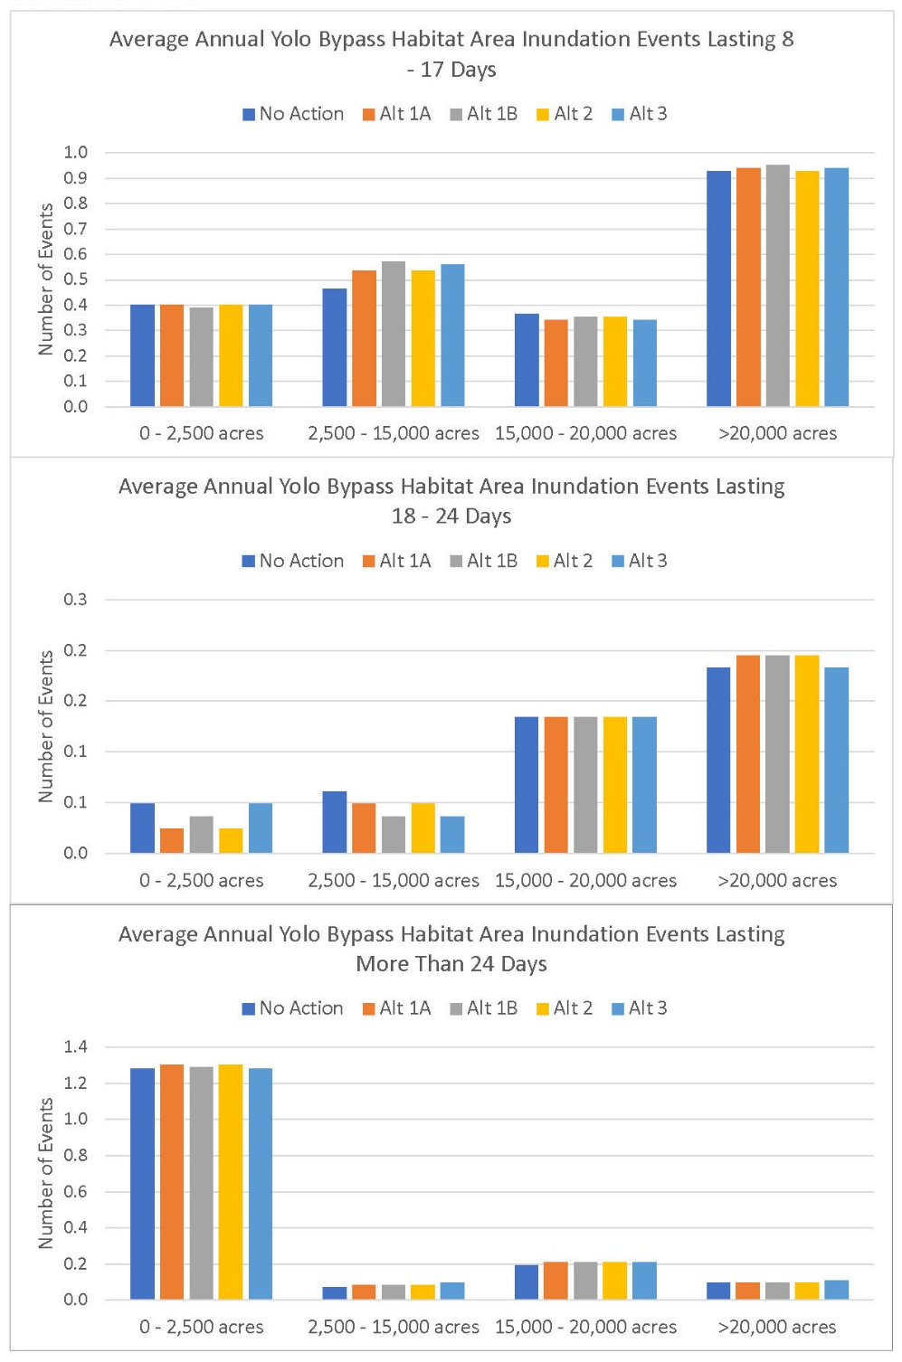
Figure 11M-8. Average Annual Number of Yolo Bypass Inundation Events with Three Different Ranges of Duration and Four Ranges of Suitable Habitat Acreages for the No Action Alternative (NAA) and Alternatives 1–3 (Alt 1A, Alt 1B, Alt 2, and Alt 3).

Sutter Bypass Weir Spill Events and Inundated Floodplain Habitat Area
Results for the Sutter Bypass weir spill events are provided in Attachment 2, Table 1. The results suggest that there would be several fewer weir spill events into the Sutter Bypass under Alternatives 1, 2, and 3 than the NAA, especially for spills lasting more than 45 days. This result indicates that opportunities for juvenile salmonids to enter the Sutter Bypass for rearing would be lower under Alternatives 1, 2, and 3 relative to the NAA. Note that flow in the Sutter Bypass greater than 3,000 cfs results in reduction of suitable habitat.
The Sutter Bypass when inundated, as discussed for the Yolo Bypass, provides important rearing habitat for juvenile Chinook salmon and steelhead and spawning and rearing habitat for Sacramento splittail (Moyle 2004; Feyrer et al. 2006b; Cordoleani et al. 2020; Bellido-Leiva et al. 2021). For the Sutter Bypass, however, the modeling results indicate that Alternatives 1, 2, and 3 would produce very little change in mean daily suitable habitat compared to the NAA (Table 11M-4). The largest differences are an increase of 54 acres for April of Wet Water Years under Alternative 3 and a reduction 58 acres for December of Dry Water Years under Alternative 3. Both differences are less than 1%. The results of the frequency analysis of inundation of events similarly show little to no differences between the NAA and Alternatives 1, 2, and 3 (Figure 11M-9). Tables providing the results plotted in Figure 11M-9 and frequency of inundation tables for every month are provided in Attachment 4. Alternatives 1, 2, and 3 are expected to have little effect on availability of suitable inundated fish habitat in the Sutter Bypass.
Table 11M-4. Estimated Mean Daily Inundated Habitat (Acres <1 Meter Deep) for Juvenile Salmonids in the Sutter Bypass and the Percent Differences (in parentheses) for the No Action Alternative (NAA) and Alternatives 1–3 (Alt 1A, Alt 1B, Alt 2, and Alt 3).
Month | Water Year Type | NAA | Alt 1A | Alt 1B | Alt 2 | Alt 3
January | Wet | 7,992 | 8,003 (0.1%) | 8,005 (0.2%) | 8,002 (0.1%) | 8,006 (0.2%)
 | Above Normal | 7,966 | 7,999 (0.4%) | 7,998 (0.4%) | 7,998 (0.4%) | 7,999 (0.4%)
 | Below Normal | 8,354 | 8,363 (0.1%) | 8,362 (0.1%) | 8,363 (0.1%) | 8,361 (0.1%)
 | Dry | 8,308 | 8,313 (0.1%) | 8,310 (0%) | 8,313 (0.1%) | 8,310 (0%)
 | Critically Dry | 7,687 | 7,691 (0%) | 7,691 (0%) | 7,691 (0%) | 7,691 (0%)
 | All | 8,075 | 8,086 (0.1%) | 8,086 (0.1%) | 8,086 (0.1%) | 8,086 (0.1%)
February | Wet | 7,580 | 7,607 (0.4%) | 7,604 (0.3%) | 7,606 (0.3%) | 7,604 (0.3%)
 | Above Normal | 7,891 | 7,936 (0.6%) | 7,943 (0.6%) | 7,936 (0.6%) | 7,910 (0.2%)
 | Below Normal | 8,715 | 8,734 (0.2%) | 8,722 (0.1%) | 8,734 (0.2%) | 8,723 (0.1%)
 | Dry | 8,726 | 8,744 (0.2%) | 8,745 (0.2%) | 8,744 (0.2%) | 8,746 (0.2%)
 | Critically Dry | 8,537 | 8,541 (0%) | 8,540 (0%) | 8,541 (0%) | 8,541 (0%)
 | All | 8,212 | 8,235 (0.3%) | 8,233 (0.3%) | 8,234 (0.3%) | 8,228 (0.2%)
March | Wet | 7,988 | 8,009 (0.3%) | 8,011 (0.3%) | 8,002 (0.2%) | 8,020 (0.4%)
 | Above Normal | 8,266 | 8,304 (0.5%) | 8,304 (0.4%) | 8,303 (0.4%) | 8,312 (0.5%)
 | Below Normal | 9,095 | 9,137 (0.5%) | 9,137 (0.5%) | 9,140 (0.5%) | 9,141 (0.5%)
 | Dry | 9,186 | 9,205 (0.2%) | 9,206 (0.2%) | 9,204 (0.2%) | 9,201 (0.2%)
 | Critically Dry | 9,041 | 9,045 (0%) | 9,045 (0%) | 9,045 (0%) | 9,045 (0%)
 | All | 8,635 | 8,659 (0.3%) | 8,660 (0.3%) | 8,657 (0.3%) | 8,663 (0.3%)
April | Wet | 8,243 | 8,280 (0.4%) | 8,288 (0.5%) | 8,272 (0.4%) | 8,298 (0.7%)
 | Above Normal | 9,125 | 9,128 (0%) | 9,125 (0%) | 9,128 (0%) | 9,126 (0%)
 | Below Normal | 9,508 | 9,517 (0.1%) | 9,517 (0.1%) | 9,517 (0.1%) | 9,517 (0.1%)
 | Dry | 9,451 | 9,455 (0%) | 9,454 (0%) | 9,455 (0%) | 9,455 (0%)
 | Critically Dry | 8,791 | 8,791 (0%) | 8,791 (0%) | 8,791 (0%) | 8,791 (0%)
 | All | 8,934 | 8,948 (0.2%) | 8,950 (0.2%) | 8,945 (0.1%) | 8,953 (0.2%)
May | Wet | 9,203 | 9,208 (0.1%) | 9,210 (0.1%) | 9,208 (0.1%) | 9,211 (0.1%)
 | Above Normal | 9,483 | 9,483 (0%) | 9,483 (0%) | 9,483 (0%) | 9,483 (0%)
 | Below Normal | 9,381 | 9,377 (0%) | 9,376 (-0.1%) | 9,377 (0%) | 9,373 (-0.1%)
 | Dry | 9,018 | 9,018 (0%) | 9,018 (0%) | 9,018 (0%) | 9,018 (0%)
 | Critically Dry | 8,166 | 8,166 (0%) | 8,166 (0%) | 8,166 (0%) | 8,166 (0%)
 | All | 9,082 | 9,083 (0%) | 9,084 (0%) | 9,083 (0%) | 9,083 (0%)
June | Wet | 9,273 | 9,274 (0%) | 9,274 (0%) | 9,274 (0%) | 9,274 (0%)
 | Above Normal | 8,876 | 8,876 (0%) | 8,876 (0%) | 8,876 (0%) | 8,876 (0%)
 | Below Normal | 8,358 | 8,358 (0%) | 8,358 (0%) | 8,358 (0%) | 8,358 (0%)
 | Dry | 7,755 | 7,755 (0%) | 7,755 (0%) | 7,755 (0%) | 7,755 (0%)
 | Critically Dry | 6,736 | 6,736 (0%) | 6,736 (0%) | 6,736 (0%) | 6,736 (0%)
 | All | 8,354 | 8,355 (0%) | 8,355 (0%) | 8,355 (0%) | 8,355 (0%)
July | Wet | 8,213 | 8,213 (0%) | 8,213 (0%) | 8,213 (0%) | 8,213 (0%)
 | Above Normal | 7,349 | 7,349 (0%) | 7,349 (0%) | 7,349 (0%) | 7,349 (0%)
 | Below Normal | 6,271 | 6,271 (0%) | 6,271 (0%) | 6,271 (0%) | 6,271 (0%)
 | Dry | 5,254 | 5,254 (0%) | 5,254 (0%) | 5,254 (0%) | 5,254 (0%)
 | Critically Dry | 4,118 | 4,118 (0%) | 4,118 (0%) | 4,118 (0%) | 4,118 (0%)
 | All | 6,506 | 6,506 (0%) | 6,506 (0%) | 6,506 (0%) | 6,506 (0%)
August | Wet | 7,187 | 7,187 (0%) | 7,187 (0%) | 7,187 (0%) | 7,187 (0%)
 | Above Normal | 5,963 | 5,963 (0%) | 5,963 (0%) | 5,963 (0%) | 5,963 (0%)
 | Below Normal | 4,257 | 4,257 (0%) | 4,257 (0%) | 4,257 (0%) | 4,257 (0%)
 | Dry | 3,204 | 3,204 (0%) | 3,204 (0%) | 3,204 (0%) | 3,204 (0%)
 | Critically Dry | 2,447 | 2,447 (0%) | 2,447 (0%) | 2,447 (0%) | 2,447 (0%)
 | All | 4,940 | 4,940 (0%) | 4,940 (0%) | 4,940 (0%) | 4,940 (0%)
September | Wet | 6,644 | 6,644 (0%) | 6,644 (0%) | 6,644 (0%) | 6,644 (0%)
 | Above Normal | 5,612 | 5,612 (0%) | 5,612 (0%) | 5,612 (0%) | 5,612 (0%)
 | Below Normal | 3,682 | 3,682 (0%) | 3,682 (0%) | 3,682 (0%) | 3,682 (0%)
 | Dry | 3,385 | 3,385 (0%) | 3,385 (0%) | 3,385 (0%) | 3,385 (0%)
 | Critically Dry | 2,346 | 2,346 (0%) | 2,346 (0%) | 2,346 (0%) | 2,346 (0%)
 | All | 4,643 | 4,643 (0%) | 4,643 (0%) | 4,643 (0%) | 4,643 (0%)
October | Wet | 6,451 | 6,451 (0%) | 6,451 (0%) | 6,451 (0%) | 6,450 (0%)
 | Above Normal | 5,699 | 5,699 (0%) | 5,699 (0%) | 5,699 (0%) | 5,699 (0%)
 | Below Normal | 5,069 | 5,069 (0%) | 5,069 (0%) | 5,069 (0%) | 5,069 (0%)
 | Dry | 5,391 | 5,391 (0%) | 5,391 (0%) | 5,391 (0%) | 5,391 (0%)
 | Critically Dry | 4,959 | 4,959 (0%) | 4,959 (0%) | 4,959 (0%) | 4,959 (0%)
 | All | 5,654 | 5,654 (0%) | 5,653 (0%) | 5,653 (0%) | 5,653 (0%)
November | Wet | 7,809 | 7,809 (0%) | 7,809 (0%) | 7,809 (0%) | 7,809 (0%)
 | Above Normal | 7,640 | 7,640 (0%) | 7,639 (0%) | 7,640 (0%) | 7,639 (0%)
 | Below Normal | 7,168 | 7,168 (0%) | 7,168 (0%) | 7,168 (0%) | 7,168 (0%)
 | Dry | 7,097 | 7,098 (0%) | 7,098 (0%) | 7,098 (0%) | 7,098 (0%)
 | Critically Dry | 5,850 | 5,850 (0%) | 5,850 (0%) | 5,850 (0%) | 5,850 (0%)
 | All | 7,232 | 7,232 (0%) | 7,232 (0%) | 7,232 (0%) | 7,232 (0%)
December | Wet | 8,193 | 8,200 (0.1%) | 8,212 (0.2%) | 8,200 (0.1%) | 8,206 (0.2%)
 | Above Normal | 8,027 | 8,038 (0.1%) | 8,037 (0.1%) | 8,037 (0.1%) | 8,039 (0.1%)
 | Below Normal | 7,698 | 7,701 (0%) | 7,700 (0%) | 7,701 (0%) | 7,700 (0%)
 | Dry | 8,045 | 8,048 (0%) | 8,028 (-0.2%) | 8,048 (0%) | 7,987 (-0.7%)
 | Critically Dry | 6,900 | 6,900 (0%) | 6,900 (0%) | 6,900 (0%) | 6,900 (0%)
 | All | 7,862 | 7,868 (0.1%) | 7,867 (0.1%) | 7,867 (0.1%) | 7,856 (-0.1%)

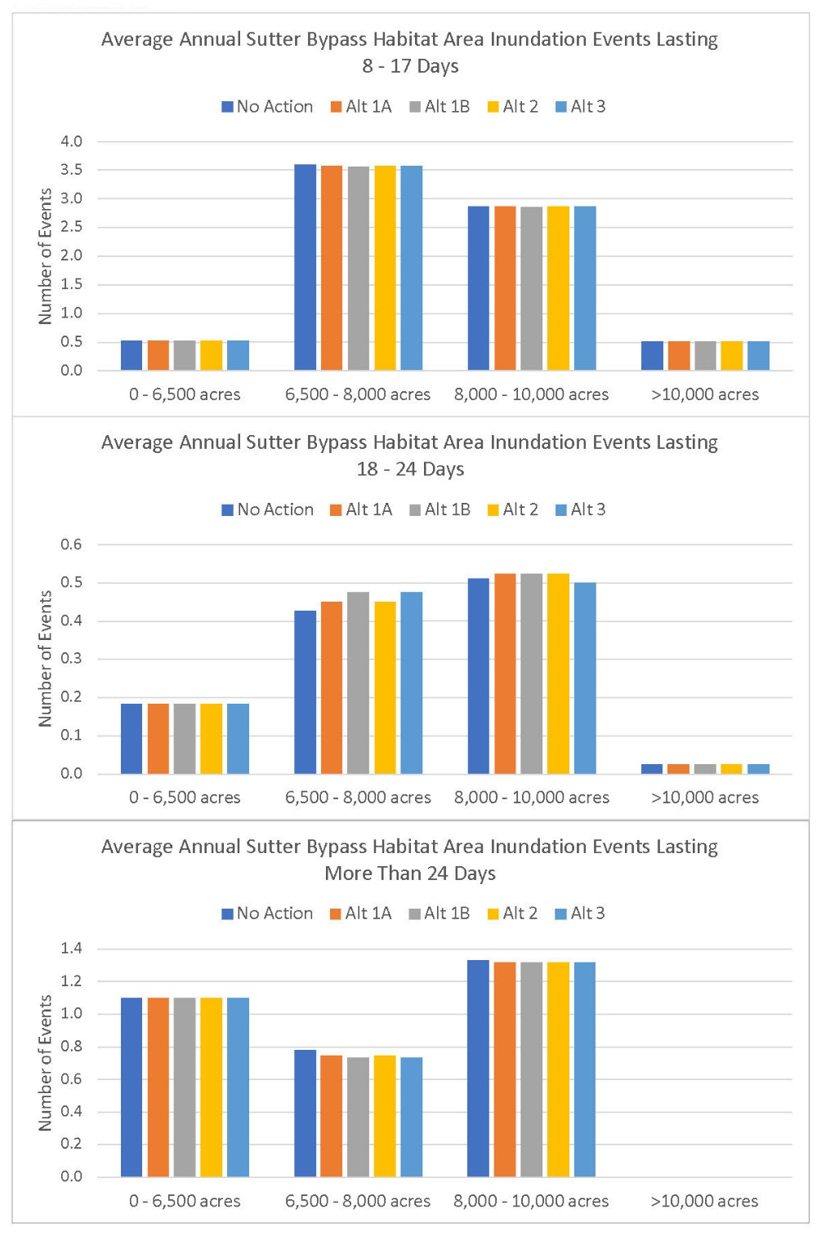
Figure 11M-9. Average Annual Number of Sutter Bypass Inundation Events with Three Different Ranges of Duration and Four Ranges of Suitable Habitat Acreages for the No Action Alternative (NAA) and Alternatives 1–3 (Alt 1A, Alt 1B, Alt 2, and Alt 3).

Sacramento River Side-Channel Habitat Area
Like the floodplain habitat of the Yolo and Sutter Bypasses, inundated side-channel habitat in the Sacramento River provides important habitat for several fish species, including Chinook salmon, steelhead, and Sacramento splittail. Juvenile salmon and steelhead use inundated side-channel habitat for rearing and Sacramento splittail use it for spawning and rearing (Moyle et al. 2004; Feyrer et al. 2005; Limm and Marchetti 2009; Moyle et al. 2015; Bellido-Leiva et al. 2021). Rearing juvenile salmon and steelhead use side-channel habitat, when it is available and water temperature is suitable, along the full length of the lower Sacramento River from Keswick Dam to the Delta. Adult Sacramento splittail have been found as far upstream as RBDD, although juveniles have not been found upstream of about Colusa, so the upstream limit of splittail spawning is uncertain (Moyle et al. 2004; Feyrer et al. 2005).
The modeling results for acreage of suitable side-channel habitat in the three reaches of the Sacramento River analyzed indicate that Alternatives 1, 2, and 3 would produce minor changes in mean daily suitable habitat as compared to the NAA in all three reaches (Table 11M-5, Table 11M-6, and Table 11M-7). None of the differences for Reach 1 are greater than 5% and none of those for Reaches 2 and 3 are greater than 6%. The largest differences are an increase of 34 acres in Reach 1 for November of Critically Dry Water Years under Alternative 3 and a reduction of 97 acres in Reach 2 for March of Above Normal Water Years under Alternative 3.
Table 11M-5. Estimated Mean Daily Side-Channel Habitat (Acres <1 Meter Deep) for Juvenile Salmonids in the Sacramento River Reach 1 (Bend Bridge to Hamilton City) and the Percent Differences (in parentheses) for the No Action Alternative (NAA) and Alternatives 1–3 (Alt 1A, Alt 1B, Alt 2, and Alt 3).
Month | Water Year Type | NAA | Alt 1A | Alt 1B | Alt 2 | Alt 3
January | Wet | 1,368 | 1,348 (-1.4%) | 1,348 (-1.5%) | 1,348 (-1.4%) | 1,352 (-1.1%)
 | Above Normal | 1,137 | 1,109 (-2.5%) | 1,110 (-2.4%) | 1,109 (-2.5%) | 1,110 (-2.4%)
 | Below Normal | 1,092 | 1,080 (-1.2%) | 1,079 (-1.2%) | 1,079 (-1.2%) | 1,079 (-1.2%)
 | Dry | 1,037 | 1,020 (-1.6%) | 1,021 (-1.5%) | 1,020 (-1.6%) | 1,022 (-1.5%)
 | Critically Dry | 1,035 | 1,020 (-1.5%) | 1,019 (-1.6%) | 1,019 (-1.6%) | 1,020 (-1.5%)
 | All | 1,166 | 1,147 (-1.6%) | 1,147 (-1.6%) | 1,147 (-1.6%) | 1,149 (-1.4%)
February | Wet | 1,481 | 1,460 (-1.4%) | 1,456 (-1.6%) | 1,462 (-1.3%) | 1,456 (-1.7%)
 | Above Normal | 1,198 | 1,186 (-1%) | 1,183 (-1.2%) | 1,184 (-1.1%) | 1,192 (-0.5%)
 | Below Normal | 1,112 | 1,083 (-2.6%) | 1,083 (-2.6%) | 1,080 (-2.9%) | 1,078 (-3.1%)
 | Dry | 1,057 | 1,038 (-1.8%) | 1,037 (-1.8%) | 1,038 (-1.8%) | 1,040 (-1.6%)
 | Critically Dry | 1,058 | 1,053 (-0.4%) | 1,053 (-0.4%) | 1,053 (-0.4%) | 1,053 (-0.4%)
 | All | 1,221 | 1,203 (-1.5%) | 1,201 (-1.6%) | 1,203 (-1.5%) | 1,202 (-1.5%)
March | Wet | 1,338 | 1,311 (-2%) | 1,309 (-2.2%) | 1,312 (-2%) | 1,306 (-2.4%)
 | Above Normal | 1,298 | 1,249 (-3.8%) | 1,248 (-3.8%) | 1,249 (-3.8%) | 1,247 (-3.9%)
 | Below Normal | 1,071 | 1,024 (-4.3%) | 1,025 (-4.3%) | 1,024 (-4.3%) | 1,025 (-4.3%)
 | Dry | 1,056 | 1,033 (-2.1%) | 1,029 (-2.5%) | 1,034 (-2.1%) | 1,029 (-2.5%)
 | Critically Dry | 1,064 | 1,058 (-0.5%) | 1,057 (-0.6%) | 1,058 (-0.5%) | 1,056 (-0.8%)
 | All | 1,184 | 1,155 (-2.5%) | 1,153 (-2.6%) | 1,155 (-2.5%) | 1,152 (-2.8%)
April | Wet | 1,197 | 1,183 (-1.2%) | 1,181 (-1.3%) | 1,183 (-1.2%) | 1,173 (-2%)
 | Above Normal | 1,126 | 1,115 (-0.9%) | 1,117 (-0.7%) | 1,115 (-0.9%) | 1,117 (-0.7%)
 | Below Normal | 1,013 | 1,009 (-0.4%) | 1,010 (-0.3%) | 1,009 (-0.4%) | 1,010 (-0.2%)
 | Dry | 979 | 968 (-1.2%) | 967 (-1.3%) | 968 (-1.2%) | 966 (-1.4%)
 | Critically Dry | 971 | 972 (0.1%) | 974 (0.3%) | 972 (0.1%) | 973 (0.2%)
 | All | 1,074 | 1,065 (-0.9%) | 1,065 (-0.8%) | 1,065 (-0.8%) | 1,062 (-1.1%)
May | Wet | 1,047 | 1,029 (-1.7%) | 1,029 (-1.6%) | 1,029 (-1.7%) | 1,026 (-1.9%)
 | Above Normal | 1,019 | 1,014 (-0.5%) | 1,013 (-0.6%) | 1,014 (-0.5%) | 1,013 (-0.5%)
 | Below Normal | 998 | 998 (0%) | 1,000 (0.2%) | 998 (0%) | 1,007 (0.9%)
 | Dry | 998 | 988 (-1%) | 987 (-1.1%) | 988 (-1%) | 995 (-0.3%)
 | Critically Dry | 1,019 | 999 (-2%) | 1,002 (-1.7%) | 999 (-1.9%) | 1,003 (-1.6%)
 | All | 1,020 | 1,008 (-1.1%) | 1,009 (-1.1%) | 1,008 (-1.1%) | 1,011 (-0.9%)
June | Wet | 1,081 | 1,078 (-0.3%) | 1,078 (-0.3%) | 1,078 (-0.3%) | 1,078 (-0.3%)
 | Above Normal | 1,087 | 1,087 (0%) | 1,085 (-0.2%) | 1,087 (0%) | 1,084 (-0.2%)
 | Below Normal | 1,083 | 1,079 (-0.3%) | 1,079 (-0.3%) | 1,079 (-0.3%) | 1,083 (0%)
 | Dry | 1,085 | 1,079 (-0.5%) | 1,079 (-0.5%) | 1,080 (-0.5%) | 1,082 (-0.2%)
 | Critically Dry | 1,087 | 1,082 (-0.5%) | 1,083 (-0.4%) | 1,082 (-0.5%) | 1,083 (-0.4%)
 | All | 1,084 | 1,080 (-0.3%) | 1,080 (-0.3%) | 1,080 (-0.3%) | 1,081 (-0.2%)
July | Wet | 1,096 | 1,096 (0%) | 1,096 (0%) | 1,096 (0%) | 1,096 (0%)
 | Above Normal | 1,092 | 1,091 (0%) | 1,092 (0%) | 1,091 (0%) | 1,091 (-0.1%)
 | Below Normal | 1,093 | 1,093 (0%) | 1,093 (-0.1%) | 1,093 (0%) | 1,094 (0%)
 | Dry | 1,099 | 1,097 (-0.2%) | 1,097 (-0.2%) | 1,097 (-0.2%) | 1,097 (-0.2%)
 | Critically Dry | 1,091 | 1,092 (0.1%) | 1,092 (0%) | 1,092 (0.1%) | 1,092 (0%)
 | All | 1,095 | 1,095 (0%) | 1,095 (0%) | 1,095 (0%) | 1,094 (-0.1%)
August | Wet | 1,098 | 1,098 (-0.1%) | 1,098 (-0.1%) | 1,098 (0%) | 1,098 (-0.1%)
 | Above Normal | 1,098 | 1,098 (0%) | 1,098 (0%) | 1,098 (0%) | 1,095 (-0.3%)
 | Below Normal | 1,093 | 1,094 (0%) | 1,094 (0%) | 1,094 (0%) | 1,093 (0%)
 | Dry | 1,092 | 1,096 (0.4%) | 1,096 (0.4%) | 1,096 (0.4%) | 1,094 (0.2%)
 | Critically Dry | 1,082 | 1,083 (0.1%) | 1,085 (0.3%) | 1,084 (0.2%) | 1,083 (0.1%)
 | All | 1,094 | 1,095 (0.1%) | 1,095 (0.1%) | 1,095 (0.1%) | 1,094 (0%)
September | Wet | 1,098 | 1,096 (-0.2%) | 1,096 (-0.1%) | 1,096 (-0.1%) | 1,096 (-0.1%)
 | Above Normal | 1,093 | 1,095 (0.1%) | 1,098 (0.4%) | 1,095 (0.1%) | 1,100 (0.6%)
 | Below Normal | 1,046 | 1,048 (0.2%) | 1,052 (0.6%) | 1,048 (0.2%) | 1,055 (0.8%)
 | Dry | 998 | 1,023 (2.5%) | 1,025 (2.8%) | 1,023 (2.5%) | 1,018 (2%)
 | Critically Dry | 979 | 999 (2%) | 1,001 (2.2%) | 1,000 (2.1%) | 998 (1.9%)
 | All | 1,049 | 1,057 (0.8%) | 1,059 (1%) | 1,058 (0.8%) | 1,058 (0.9%)
October | Wet | 1,064 | 1,074 (0.9%) | 1,080 (1.5%) | 1,074 (0.9%) | 1,071 (0.7%)
 | Above Normal | 1,063 | 1,080 (1.5%) | 1,074 (1%) | 1,078 (1.4%) | 1,075 (1.1%)
 | Below Normal | 1,048 | 1,061 (1.3%) | 1,063 (1.4%) | 1,064 (1.5%) | 1,061 (1.2%)
 | Dry | 1,059 | 1,061 (0.2%) | 1,061 (0.2%) | 1,062 (0.2%) | 1,065 (0.6%)
 | Critically Dry | 991 | 1,010 (1.9%) | 998 (0.6%) | 1,010 (1.9%) | 1,025 (3.4%)
 | All | 1,049 | 1,060 (1%) | 1,060 (1%) | 1,061 (1.1%) | 1,062 (1.2%)
November | Wet | 1,077 | 1,074 (-0.2%) | 1,077 (0%) | 1,074 (-0.2%) | 1,079 (0.2%)
 | Above Normal | 1,068 | 1,075 (0.7%) | 1,077 (0.9%) | 1,066 (-0.2%) | 1,078 (0.9%)
 | Below Normal | 1,053 | 1,046 (-0.7%) | 1,046 (-0.6%) | 1,047 (-0.6%) | 1,050 (-0.3%)
 | Dry | 1,068 | 1,068 (0%) | 1,066 (-0.2%) | 1,068 (0%) | 1,065 (-0.2%)
 | Critically Dry | 1,022 | 1,030 (0.7%) | 1,039 (1.7%) | 1,036 (1.3%) | 1,057 (3.4%)
 | All | 1,061 | 1,061 (0%) | 1,064 (0.2%) | 1,061 (0%) | 1,068 (0.6%)
December | Wet | 1,178 | 1,174 (-0.3%) | 1,172 (-0.5%) | 1,175 (-0.3%) | 1,171 (-0.6%)
 | Above Normal | 1,064 | 1,027 (-3.6%) | 1,028 (-3.4%) | 1,026 (-3.6%) | 1,027 (-3.5%)
 | Below Normal | 1,065 | 1,052 (-1.2%) | 1,052 (-1.2%) | 1,051 (-1.3%) | 1,054 (-1.1%)
 | Dry | 1,056 | 1,047 (-0.8%) | 1,045 (-1%) | 1,045 (-1%) | 1,040 (-1.5%)
 | Critically Dry | 1,026 | 1,016 (-0.9%) | 1,019 (-0.6%) | 1,019 (-0.6%) | 1,025 (-0.1%)
 | All | 1,093 | 1,081 (-1.1%) | 1,080 (-1.2%) | 1,081 (-1.1%) | 1,080 (-1.2%)

Table 11M-6. Estimated Mean Daily Side-Channel Habitat (Acres <1 Meter Deep) for Juvenile Salmonids in the Sacramento River Reach 2 (Hamilton City to Colusa) and the Percent Differences (in parentheses) for the No Action Alternative (NAA) and Alternatives 1–3 (Alt 1A, Alt 1B, Alt 2, and Alt 3).
Month | Water Year Type | NAA | Alt 1A | Alt 1B | Alt 2 | Alt 3
January | Wet | 1,933 | 1,889 (-2.2%) | 1,887 (-2.3%) | 1,892 (-2.1%) | 1,890 (-2.2%)
 | Above Normal | 1,508 | 1,435 (-4.8%) | 1,436 (-4.8%) | 1,434 (-4.8%) | 1,435 (-4.8%)
 | Below Normal | 1,000 | 978 (-2.2%) | 979 (-2.1%) | 978 (-2.1%) | 980 (-2%)
 | Dry | 792 | 783 (-1.2%) | 784 (-1%) | 783 (-1.2%) | 785 (-0.9%)
 | Critically Dry | 754 | 748 (-0.7%) | 746 (-1%) | 746 (-0.9%) | 746 (-1%)
 | All | 1,288 | 1,257 (-2.4%) | 1,257 (-2.4%) | 1,258 (-2.4%) | 1,258 (-2.3%)
February | Wet | 2,418 | 2,353 (-2.7%) | 2,348 (-2.9%) | 2,360 (-2.4%) | 2,355 (-2.6%)
 | Above Normal | 1,659 | 1,594 (-3.9%) | 1,575 (-5%) | 1,589 (-4.2%) | 1,610 (-3%)
 | Below Normal | 1,081 | 1,050 (-2.9%) | 1,052 (-2.7%) | 1,045 (-3.4%) | 1,052 (-2.7%)
 | Dry | 950 | 922 (-2.9%) | 921 (-3.1%) | 922 (-2.9%) | 920 (-3.2%)
 | Critically Dry | 769 | 765 (-0.6%) | 764 (-0.7%) | 764 (-0.7%) | 765 (-0.6%)
 | All | 1,514 | 1,472 (-2.8%) | 1,467 (-3.1%) | 1,472 (-2.8%) | 1,475 (-2.6%)
March | Wet | 1,928 | 1,888 (-2.1%) | 1,882 (-2.4%) | 1,895 (-1.7%) | 1,868 (-3.1%)
 | Above Normal | 1,768 | 1,680 (-5%) | 1,680 (-5%) | 1,681 (-4.9%) | 1,671 (-5.5%)
 | Below Normal | 936 | 893 (-4.5%) | 893 (-4.5%) | 890 (-4.8%) | 895 (-4.3%)
 | Dry | 885 | 843 (-4.8%) | 840 (-5.1%) | 846 (-4.4%) | 846 (-4.4%)
 | Critically Dry | 743 | 735 (-1.1%) | 732 (-1.5%) | 735 (-1.1%) | 735 (-1.1%)
 | All | 1,333 | 1,290 (-3.3%) | 1,287 (-3.5%) | 1,292 (-3.1%) | 1,283 (-3.8%)
April | Wet | 1,555 | 1,508 (-3.1%) | 1,501 (-3.5%) | 1,515 (-2.6%) | 1,487 (-4.4%)
 | Above Normal | 1,104 | 1,086 (-1.7%) | 1,089 (-1.4%) | 1,086 (-1.7%) | 1,088 (-1.5%)
 | Below Normal | 779 | 765 (-1.8%) | 766 (-1.7%) | 765 (-1.8%) | 766 (-1.7%)
 | Dry | 729 | 720 (-1.2%) | 722 (-1%) | 720 (-1.1%) | 722 (-0.9%)
 | Critically Dry | 697 | 696 (0%) | 697 (0%) | 696 (0%) | 696 (-0.1%)
 | All | 1,050 | 1,027 (-2.1%) | 1,026 (-2.2%) | 1,030 (-1.9%) | 1,022 (-2.7%)
May | Wet | 879 | 863 (-1.8%) | 857 (-2.5%) | 863 (-1.8%) | 854 (-2.8%)
 | Above Normal | 818 | 816 (-0.3%) | 816 (-0.3%) | 816 (-0.3%) | 816 (-0.3%)
 | Below Normal | 735 | 735 (-0.1%) | 736 (0%) | 735 (-0.1%) | 737 (0.2%)
 | Dry | 708 | 702 (-0.8%) | 702 (-0.8%) | 702 (-0.8%) | 704 (-0.5%)
 | Critically Dry | 702 | 701 (-0.1%) | 703 (0.1%) | 702 (0%) | 702 (0%)
 | All | 782 | 775 (-0.9%) | 774 (-1.1%) | 775 (-0.8%) | 773 (-1.1%)
June | Wet | 809 | 802 (-0.8%) | 800 (-1.1%) | 802 (-0.8%) | 798 (-1.3%)
 | Above Normal | 731 | 723 (-1.2%) | 721 (-1.5%) | 723 (-1.2%) | 722 (-1.3%)
 | Below Normal | 728 | 728 (0.1%) | 727 (-0.1%) | 728 (0.1%) | 723 (-0.7%)
 | Dry | 739 | 740 (0.2%) | 742 (0.4%) | 740 (0.1%) | 742 (0.4%)
 | Critically Dry | 710 | 712 (0.2%) | 712 (0.2%) | 712 (0.3%) | 711 (0.1%)
 | All | 754 | 751 (-0.4%) | 750 (-0.5%) | 751 (-0.4%) | 749 (-0.6%)
July | Wet | 763 | 760 (-0.4%) | 760 (-0.4%) | 760 (-0.4%) | 760 (-0.4%)
 | Above Normal | 800 | 800 (-0.1%) | 797 (-0.4%) | 800 (-0.1%) | 805 (0.7%)
 | Below Normal | 771 | 775 (0.5%) | 774 (0.4%) | 775 (0.5%) | 776 (0.8%)
 | Dry | 752 | 780 (3.7%) | 781 (3.8%) | 780 (3.7%) | 778 (3.5%)
 | Critically Dry | 715 | 731 (2.3%) | 731 (2.3%) | 728 (1.9%) | 724 (1.3%)
 | All | 760 | 768 (1.1%) | 768 (1%) | 768 (1%) | 768 (1.1%)
August | Wet | 733 | 731 (-0.3%) | 731 (-0.3%) | 732 (-0.2%) | 731 (-0.3%)
 | Above Normal | 735 | 735 (0%) | 738 (0.4%) | 735 (0%) | 733 (-0.3%)
 | Below Normal | 708 | 710 (0.3%) | 711 (0.4%) | 710 (0.3%) | 713 (0.7%)
 | Dry | 707 | 720 (1.9%) | 718 (1.7%) | 719 (1.8%) | 715 (1.2%)
 | Critically Dry | 706 | 709 (0.5%) | 707 (0.2%) | 707 (0.1%) | 711 (0.8%)
 | All | 719 | 723 (0.4%) | 722 (0.4%) | 722 (0.4%) | 722 (0.3%)
September | Wet | 776 | 773 (-0.3%) | 775 (-0.1%) | 775 (-0.1%) | 773 (-0.3%)
 | Above Normal | 709 | 710 (0.1%) | 712 (0.3%) | 710 (0.1%) | 717 (1.1%)
 | Below Normal | 696 | 696 (0%) | 699 (0.4%) | 696 (-0.1%) | 698 (0.2%)
 | Dry | 676 | 686 (1.6%) | 690 (2.1%) | 687 (1.7%) | 685 (1.4%)
 | Critically Dry | 657 | 672 (2.3%) | 672 (2.3%) | 673 (2.4%) | 670 (2%)
 | All | 713 | 717 (0.5%) | 719 (0.9%) | 718 (0.6%) | 718 (0.6%)
October | Wet | 733 | 731 (-0.3%) | 735 (0.4%) | 731 (-0.2%) | 731 (-0.2%)
 | Above Normal | 714 | 715 (0.1%) | 717 (0.4%) | 716 (0.3%) | 720 (0.8%)
 | Below Normal | 707 | 710 (0.4%) | 710 (0.5%) | 713 (0.8%) | 709 (0.4%)
 | Dry | 705 | 701 (-0.6%) | 702 (-0.4%) | 702 (-0.5%) | 703 (-0.3%)
 | Critically Dry | 681 | 680 (-0.1%) | 678 (-0.5%) | 680 (-0.1%) | 697 (2.4%)
 | All | 712 | 711 (-0.1%) | 713 (0.1%) | 712 (0%) | 715 (0.4%)
November | Wet | 821 | 818 (-0.4%) | 824 (0.3%) | 818 (-0.4%) | 827 (0.7%)
 | Above Normal | 733 | 736 (0.5%) | 736 (0.5%) | 730 (-0.4%) | 734 (0.2%)
 | Below Normal | 715 | 713 (-0.3%) | 713 (-0.2%) | 712 (-0.3%) | 714 (0%)
 | Dry | 730 | 728 (-0.3%) | 729 (-0.1%) | 728 (-0.3%) | 731 (0.1%)
 | Critically Dry | 695 | 704 (1.3%) | 701 (0.8%) | 702 (1%) | 714 (2.8%)
 | All | 752 | 752 (0%) | 753 (0.2%) | 750 (-0.2%) | 757 (0.7%)
December | Wet | 1,474 | 1,461 (-0.9%) | 1,454 (-1.4%) | 1,463 (-0.8%) | 1460 (-1%)
 | Above Normal | 923 | 886 (-4.1%) | 886 (-4.1%) | 884 (-4.2%) | 886 (-4%)
 | Below Normal | 818 | 811 (-0.8%) | 812 (-0.6%) | 811 (-0.8%) | 814 (-0.4%)
 | Dry | 797 | 790 (-0.8%) | 805 (1%) | 790 (-0.9%) | 820 (2.9%)
 | Critically Dry | 713 | 716 (0.5%) | 714 (0.1%) | 714 (0.1%) | 719 (0.9%)
 | All | 1,021 | 1,010 (-1.1%) | 1,010 (-1.1%) | 1,009 (-1.2%) | 1,017 (-0.5%)
* Results for which habitat acreage under Alternative 1, 2, or 3 is more than 5% below habitat acreage under the NAA are highlighted green.
^ Results for which habitat acreage under Alternative 1, 2, or 3 is more than 10% higher than habitat acreage under the NAA are highlighted red.
Table 11M-7. Estimated Mean Daily Side-Channel Habitat (Acres <1 Meter Deep) for Juvenile Salmonids in the Sacramento River Reach 3 (Colusa to Knights Landing) and the Percent Differences (in parentheses) for the No Action Alternative (NAA) and Alternatives 1–3 (Alt 1A, Alt 1B, Alt 2, and Alt 3).
Month | Water Year Type | NAA | Alt 1A | Alt 1B | Alt 2 | Alt 3
January | Wet | 250 | 243 (-3.1%) | 242 (-3.5%) | 243 (-2.9%) | 242 (-3.5%)
 | Above Normal | 226 | 213 (-5.6%) | 214 (-5.6%) | 213 (-5.6%) | 213 (-5.6%)
 | Below Normal | 138 | 135 (-1.8%) | 135 (-1.7%) | 135 (-1.8%) | 135 (-1.6%)
 | Dry | 120 | 120 (-0.1%) | 121 (0.2%) | 120 (0%) | 121 (0.2%)
 | Critically Dry | 112 | 112 (0.6%) | 113 (1%) | 113 (0.9%) | 113 (1.2%)
 | All | 179 | 174 (-2.6%) | 174 (-2.7%) | 174 (-2.5%) | 174 (-2.7%)
February | Wet | 321 | 314 (-2.1%) | 315 (-1.8%) | 314 (-2.1%) | 317 (-1.1%)
 | Above Normal | 245 | 233 (-4.8%) | 232 (-5.3%) | 233 (-4.8%) | 234 (-4.7%)
 | Below Normal | 152 | 148 (-2.3%) | 151 (-0.5%) | 148 (-2.4%) | 153 (0.9%)
 | Dry | 143 | 139 (-2.4%) | 139 (-2.5%) | 139 (-2.4%) | 139 (-2.8%)
 | Critically Dry | 110 | 109 (-0.7%) | 109 (-0.7%) | 109 (-0.7%) | 109 (-0.5%)
 | All | 211 | 205 (-2.5%) | 206 (-2.3%) | 205 (-2.5%) | 207 (-1.7%)
March | Wet | 256 | 254 (-1.1%) | 253 (-1.2%) | 254 (-0.7%) | 251 (-2.3%)
 | Above Normal | 243 | 232 (-4.7%) | 232 (-4.6%) | 232 (-4.6%) | 231 (-5.2%)
 | Below Normal | 129 | 127 (-1.8%) | 127 (-1.9%) | 126 (-2.3%) | 127 (-1.4%)
 | Dry | 123 | 117 (-5.2%) | 116 (-5.5%) | 117 (-4.9%) | 118 (-4.4%)
 | Critically Dry | 102 | 101 (-1.6%) | 101 (-1.9%) | 101 (-1.6%) | 102 (-0.7%)
 | All | 181 | 176 (-2.5%) | 176 (-2.7%) | 177 (-2.4%) | 176 (-2.9%)
April | Wet | 231 | 222 (-3.9%) | 220 (-4.5%) | 223 (-3.3%) | 219 (-5.3%)
 | Above Normal | 151 | 148 (-1.8%) | 149 (-1.5%) | 148 (-1.8%) | 148 (-1.6%)
 | Below Normal | 112 | 108 (-3.7%) | 108 (-3.8%) | 108 (-3.7%) | 108 (-3.8%)
 | Dry | 109 | 109 (-0.6%) | 109 (-0.5%) | 109 (-0.5%) | 109 (-0.2%)
 | Critically Dry | 113 | 113 (0.7%) | 113 (0.6%) | 113 (0.7%) | 113 (0.6%)
 | All | 155 | 151 (-2.6%) | 150 (-2.8%) | 151 (-2.3%) | 150 (-3.2%)
May | Wet | 119 | 117 (-2.2%) | 116 (-2.9%) | 117 (-2.1%) | 115 (-3.5%)
 | Above Normal | 128 | 128 (-0.1%) | 128 (-0.1%) | 128 (-0.1%) | 128 (-0.1%)
 | Below Normal | 119 | 119 (0.1%) | 118 (-0.3%) | 119 (0.1%) | 118 (-0.7%)
 | Dry | 115 | 114 (-0.6%) | 114 (-0.7%) | 114 (-0.6%) | 114 (-0.4%)
 | Critically Dry | 114 | 115 (0.5%) | 115 (1%) | 115 (0.7%) | 115 (0.9%)
 | All | 119 | 118 (-0.8%) | 117 (-1%) | 118 (-0.7%) | 117 (-1.2%)
June | Wet | 117 | 117 (0%) | 117 (-0.2%) | 117 (0%) | 117 (-0.3%)
 | Above Normal | 106 | 106 (-0.5%) | 107 (0.9%) | 106 (-0.5%) | 107 (1.1%)
 | Below Normal | 108 | 108 (0.4%) | 109 (1%) | 108 (0.4%) | 109 (0.7%)
 | Dry | 106 | 107 (0.9%) | 107 (0.8%) | 107 (1%) | 106 (-0.1%)
 | Critically Dry | 111 | 110 (-0.3%) | 111 (0.2%) | 111 (0.2%) | 111 (0.2%)
 | All | 111 | 111 (0.1%) | 111 (0.4%) | 111 (0.2%) | 111 (0.2%)
July | Wet | 97 | 96 (-0.2%) | 96 (-0.2%) | 96 (-0.2%) | 96 (-0.2%)
 | Above Normal | 95 | 96 (0.6%) | 96 (0.9%) | 96 (0.6%) | 99 (4.5%)
 | Below Normal | 98 | 97 (-0.5%) | 98 (0.2%) | 97 (-0.4%) | 98 (0.1%)
 | Dry | 97 | 96 (-0.7%) | 96 (-1%) | 96 (-0.8%) | 96 (-0.8%)
 | Critically Dry | 110 | 107 (-3.2%) | 107 (-3%) | 107 (-3.1%) | 107 (-3.1%)
 | All | 99 | 98 (-0.8%) | 98 (-0.6%) | 98 (-0.7%) | 99 (-0.1%)
August | Wet | 98 | 98 (0.7%) | 98 (0.7%) | 98 (0.6%) | 98 (0.7%)
 | Above Normal | 98 | 98 (0.5%) | 98 (0.8%) | 98 (0.5%) | 101 (3.3%)
 | Below Normal | 106 | 105 (-0.8%) | 105 (-0.8%) | 105 (-0.9%) | 106 (-0.6%)
 | Dry | 107 | 101 (-5.5%) | 101 (-5.5%) | 101 (-5%) | 104 (-2.8%)
 | Critically Dry | 110 | 109 (-1.1%) | 107 (-3%) | 108 (-2.3%) | 110 (-0.5%)
 | All | 103 | 102 (-1.3%) | 101 (-1.6%) | 101 (-1.4%) | 103 (-0.2%)
September | Wet | 95 | 95 (-0.2%) | 95 (0%) | 95 (-0.1%) | 95 (-0.2%)
 | Above Normal | 95 | 95 (-0.1%) | 93 (-2.8%) | 95 (-0.2%) | 91 (-4.5%)
 | Below Normal | 115 | 114 (-1%) | 114 (-0.9%) | 114 (-1%) | 113 (-1.4%)
 | Dry | 119 | 115 (-2.7%) | 117 (-1.5%) | 116 (-2.6%) | 118 (-0.6%)
 | Critically Dry | 114 | 115 (0.5%) | 115 (0.5%) | 115 (0.8%) | 115 (0.4%)
 | All | 106 | 105 (-0.9%) | 106 (-0.8%) | 106 (-0.7%) | 105 (-1%)
October | Wet | 105 | 105 (-0.5%) | 105 (0%) | 105 (-0.4%) | 104 (-1%)
 | Above Normal | 110 | 108 (-1.7%) | 109 (-1.1%) | 108 (-1.7%) | 109 (-1.2%)
 | Below Normal | 111 | 111 (-0.6%) | 110 (-1%) | 111 (0%) | 109 (-1.8%)
 | Dry | 113 | 110 (-1.9%) | 111 (-1.4%) | 110 (-1.8%) | 109 (-3%)
 | Critically Dry | 110 | 109 (-0.9%) | 110 (-0.4%) | 109 (-0.7%) | 114 (3.1%)
 | All | 109 | 108 (-1.1%) | 109 (-0.7%) | 108 (-0.9%) | 108 (-1%)
November | Wet | 121 | 122 (0.5%) | 123 (1.8%) | 122 (0.5%) | 123 (2%)
 | Above Normal | 109 | 109 (0.6%) | 109 (0.1%) | 108 (-0.3%) | 109 (-0.2%)
 | Below Normal | 111 | 111 (0.4%) | 111 (0.5%) | 111 (0.3%) | 111 (0.5%)
 | Dry | 112 | 112 (-0.3%) | 113 (0.5%) | 112 (-0.3%) | 114 (1.3%)
 | Critically Dry | 110 | 114 (3.1%) | 113 (2.8%) | 113 (2.1%) | 115 (4.7%)
 | All | 114 | 115 (0.7%) | 115 (1.2%) | 114 (0.4%) | 116 (1.7%)
December | Wet | 211 | 210 (-0.7%) | 207 (-1.9%) | 210 (-0.6%) | 208 (-1.6%)
 | Above Normal | 140 | 137 (-1.9%) | 137 (-2.4%) | 137 (-2.2%) | 137 (-2.3%)
 | Below Normal | 120 | 120 (-0.2%) | 121 (0.1%) | 120 (-0.1%) | 121 (0.6%)
 | Dry | 111 | 111 (0%) | 113 (1.9%) | 111 (0.4%) | 116 (4.4%)
 | Critically Dry | 113 | 116 (3.1%) | 115 (2.2%) | 115 (2.1%) | 115 (2%)
 | All | 149 | 149 (-0.2%) | 148 (-0.6%) | 148 (-0.3%) | 149 (0%)
* Results for which habitat acreage under Alternative 1, 2, or 3 is more than 5% below habitat acreage under the NAA are highlighted green.
^ Results for which habitat acreage under Alternative 1, 2, or 3 is more than 10% higher than habitat acreage under the NAA are highlighted red.

The results of the frequency analysis of inundation of events for all three reaches combined also show some differences between the NAA and Alternatives 1, 2, and 3 (Figure 11M-10). For events with 2,000 to 3,000 acres, the results show modest reductions in frequencies under Alternatives 1, 2, and 3 for events lasting 8–17 days and events lasting over 24 days. In contrast, for events with 2,000 to 3,000 acres lasting 18–24 days, the results show moderate increases in frequencies under Alternatives 1 and 2, but not Alternative 3. As previously noted, inundation lasting 18–24 days has been shown to result in maximum productivity in field studies (Whipple et al. 2019). Tables providing the results plotted in Figure 11M-10 and frequency of inundation tables for every month are provided in Attachment 5.
Alternatives 1, 2, and 3 would result in both reductions and increases in acreage and frequency of suitable inundated side-channel habitat in the Sacramento River. On balance, however, the effects would not be large enough to substantially affect the Chinook salmon, steelhead, and Sacramento splittail populations.

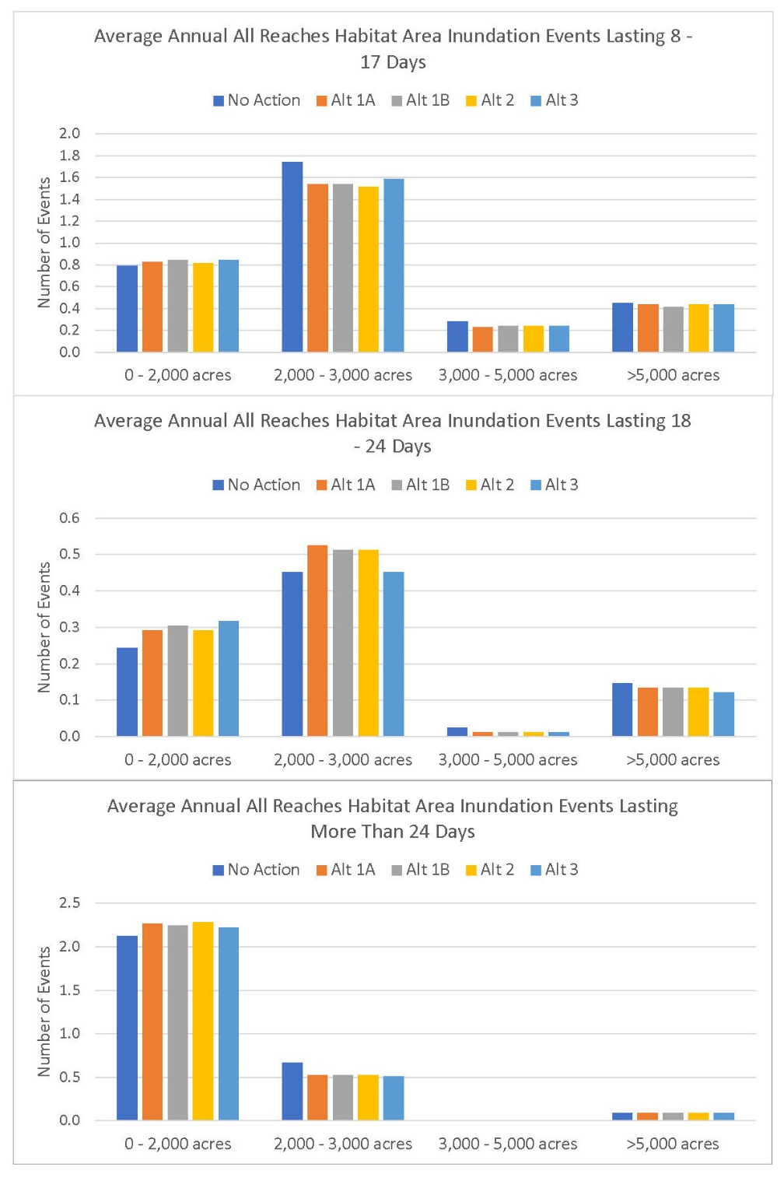
Figure 11M-10. Average Annual Number of Sacramento River Side-Channel Inundation Events (Three River Reaches Combined) with Three Different Ranges of Duration and Four Ranges of Suitable Habitat Acreages for the No Action Alternative (NAA) and Alternatives 1–3 (Alt 1A, Alt 1B, Alt 2, and Alt 3).

Conclusion
Except for the Sutter Bypass, the analyses indicated that during the winter and spring months, when inundated habitat is most important to Chinook salmon, steelhead, and Sacramento splittail, the mean daily acreages of suitable habitat are usually lower under Alternatives 1, 2, and 3 than under the NAA. However, the reductions are mostly small and unlikely to have substantial effects on the fish populations. The reductions were largest for the Yolo Bypass (Table 11M-2), but the net reduction for all January through April days was 107 acres or 1.3% (Table 11M-3). The Sutter Bypass results showed almost no reductions and many minor increases in daily habitat acreage under Alternatives 1, 2, and 3 (Table 11M-4). No consistent differences in the frequency of inundation events were found between the NAA and Alternatives 1, 2, and 3.

References Cited
Aceituno, M. E. 1990. Habitat preference criteria for Chinook salmon of the Stanislaus River, California. U.S. Department of the Interior. Fish & Wildlife Service, Sacramento, California.
Acierto, K. R., J. Israel, J. Ferreira, and J. Roberts. 2014. Estimating juvenile winter-run and spring-run Chinook salmon entrainment onto the Yolo Bypass over a notched Fremont Weir. California Fish and Game. 100(4): 630-639.
Bellido-Leiva, F. J., R. A. Lusardi, and J. R. Lund. 2021. Modeling the Effect of Habitat Availability and Quality on Endangered Winter-Run Chinook Salmon (Oncorhynchus tshawytscha) Production in The Sacramento Valley. Ecological Modelling 447.
Cordoleani, F., W. H. Satterthwaite, M. E. Daniels, M. R. Johnson. 2020. Using Life-Cycle Models to Identify Monitoring Gaps for Central Valley Spring-Run Chinook Salmon. San Francisco Estuary and Watershed Science 18(4).
Feyrer, F., T. R. Sommer, and R. Baxter. 2005. Spatial-Temporal Distribution and Habitat Associations of Age-0 Splittail in the Lower San Francisco Estuary Watershed. Copeia 2005(1):159-168.
Feyrer, F., T. Sommer, and W. Harrell. 2006a. Managing Floodplain Inundation for Native Fish: Production Dynamics of Age-0 Splittail (Pogonichthys macrolepidotus) in California’s Yolo Bypass. Hydrobiologia 573:213-226.
Feyrer, F., T. Sommer, and W. Harrell. 2006b. Importance of Flood Dynamics versus Intrinsic Physical Habitat in Structuring Fish Communities: Evidence from Two Adjacent Engineered Floodplains on the Sacramento River, California. North American Journal of Fisheries Management 26:408–417.
Hampton, M. 1997. Microhabitat Suitability Criteria for Anadromous Salmonids of the Trinity River. U. S. Fish and Wildlife Service. Arcata, CA.
Hinkelman, T. M., J. Myfanwy, and J. E. Merz. 2017. Yolo Bypass Salmon Benefits Model: Modeling the Benefits of Yolo Bypass Restoration Actions on Chinook Salmon. Prepared by Cramer Fish Sciences for United States Bureau of Reclamation and California Department of Water Resources. West Sacramento, CA.
Katz, J. V. E., C. Jeffres, J. L. Conrad, T. R. Sommer, J. Martinez, S. Brumbaugh, N. Corline, and P. B. Moyle. 2017. Floodplain Farm Fields Provide Novel Rearing Habitat for Chinook Salmon. Plos One 2017:1–16.
Limm, M. P. and M. P. Marchetti. 2009. Marchetti. Juvenile Chinook Salmon (Oncorhynchus Tshawytscha) Growth in Off-Channel and Main-Channel Habitats on the Sacramento River, CA Using Otolith Increment Widths. Environmental Biology of Fishes 85:141–151.
Moyle, P. B., R. D. Baxter, T. Sommer, T.C. Foin, and S. A. Matern. 2004. Biology and Population Dynamics of Sacramento Splittail (Pogonichthys macrolepidotus) in the San Francisco Estuary: A Review. San Francisco Estuary and Watershed Science 2(2):1–47.
Moyle, P. B., R. M. Quiñones, J. V. Katz, and J. Weaver. 2015. Fish Species of Special Concern in California. Third Edition. California Department of Fish and Wildlife. Sacramento, CA.
Sommer, T., B. Harrell, M. Nobriga, R. Brown, P. Moyle, W. Kimmerer, and L. Schemel. 2001a. California’s Yolo Bypass: Evidence that Flood Control Can Be Compatible with Fisheries, Wetlands, Wildlife, and Agriculture. Fisheries 26:6–16.
Sommer, T., R., M. L. Nobriga, W. C., Harrell, W. Batham, R. Brown, and W.J. Kimmerer. 2001b. Floodplain Rearing of Juvenile Chinook Salmon: Evidence of Enhanced Growth and Survival. Canadian Journal of Fisheries and Aquatic Sciences 58:325–333.
Sommer, T. R., L. Conrad, G. O’leary, F. Feyrer, and W. C. Harrell. 2002. Spawning and Rearing of Splittail in a Model Floodplain Wetland. Transactions of the American Fisheries Society 131:966–974.
Sommer, T. R., W. C. Harrell, R. Kurth, F. Feyrer, S. C. Zeug, G. O’Leary. 2004. Ecological Patterns of Early Life Stages of Fishes in a Large River-Floodplain of the San Francisco Estuary. American Fisheries Society Symposium 39:111–123.
Sommer, T. R., W. C. Harrell, and M. L. Nobriga. 2005. Habitat Use and Stranding Risk of Juvenile Chinook Salmon on a Seasonal Floodplain. North American Journal of Fisheries Management 25:1493–1504.
Sommer, T. R., W. C. Harrell, Z. Matica, and F. Feyrer. 2008. Habitat Associations and Behavior of Adult and Juvenile Splittail (Cyprinidae: Pogonichthys macrolepidotus) in a Managed Seasonal Floodplain Wetland. San Francisco Estuary and Watershed Science, 6(2):1–16. http://escholarship.org/uc/item/85r15611.
Takata, L., T. R. Sommer, J. L. Conrad, and B. M. Schreier. 2017. Rearing and migration of juvenile Chinook salmon (Oncorhynchus tshawytscha) in a large river floodplain. Environmental Biology of Fishes 100(9):1105-1120.
U.S. Fish and Wildlife Service. 2005. Flow-Habitat Relationships for Chinook Salmon Rearing in the Sacramento River between Keswick Dam and Battle Creek. August 2, 2005. Sacramento, CA.

Whipple A., T. Grantham, G. Desanker, L. Hunt, A. Merrill, B. Hackenjos, R. Askevold. 2019. Chinook Salmon Habitat Quantification Tool: User Guide (Version 1.0). Prepared for American Rivers. Funded by the Natural Resources Conservation Service Conservation Innovation Grant (#69-3A75-17-40), Water Foundation and Environmental Defense Fund. A report of SFEI-ASC’s Resilient Landscapes Program, Publication #953. San Francisco Estuary Institute, Richmond, CA.

