Appendix 28A Climate Change

Introduction
This document summarizes the development of the 2035 CT boundary conditions for the CalSim II model. For more details regarding the development of the 2035 CT boundary conditions, please review the Final Environmental Impact Report for Long-Term Operation of the California State Water Project (SWP LTO FEIR), Appendix F: Part 2: Attachment 1 Climate Change Projections Development (DWR, 2019).

Historical Observed Meteorological Data
Livneh et al. (2013) daily historical meteorology data at 1/16th degree (~6 km) (~3.75 miles) spatial resolution over the period 1915 through 2011 was used to develop historical VIC simulation and future climate change scenarios based on quantile mapping approach. These historical data were adjusted based on PRISM data (Daly et al., 1994) to correct biases found in the pre-1950 period. These datasets have already been reviewed under the Sacramento – San Joaquin River Basins Study, Central Valley Flood Protection Plan (CVFPP) 2017 Update, and Water Storage Investment Program (WSIP).

Future Climate Change Scenario
The climate change scenario centered around 2035 (2020-2049) was developed with the ensemble informed climate change scenarios method, using the 20 Coupled Model Intercomparison Project 5 (CMIP5) global climate model projections. With the ensemble informed climate change scenarios method, historical temperature and precipitation were adjusted with quantile mapping based on the selected global climate model projections to represent future conditions.
These projections were downscaled using the localized constructed analog (LOCA) method at 1/16th degree (approximately 6 kilometers [km], or approximately 3.75 miles) spatial resolution (Pierce et al., 2014). The LOCA method is a statistical scheme that uses future climate projections combined with historical analog events to produce daily downscaled precipitation, and maximum and minimum temperature time series data. Further details on the LOCA downscaling can be found in WSIP Technical Reference Document Appendix A (CWC, 2017).
The 20 CMIP5 global climate projections were selected by the California Department of Water Resources (DWR) Climate Change Technical Advisory Group (CCTAG) as the most appropriate projections for California water resources evaluation and planning (DWR CCTAG, 2015). The climate model projections were generated with two emission scenarios, one optimistic (Representative Concentration Pathway [RCP] 4.5) and one pessimistic (RCP 8.5), identified by the IPCC for the Fifth Assessment Report (AR5) (IPCC, 2013).
More details regarding the global climate model projections, predicted changes to temperature, and predicted changes to precipitation are provided in SWP LTO FEIR, Appendix F: Part 2: Attachment 1 Climate Change Projections Development (DWR, 2019).

VIC Model Simulations
Historical and projected surface runoff and baseflow at 1/16th degree (approximately 6 km, or 3.75 miles) were generated by inputting historical and projected meteorological data into the VIC model. The VIC Model (Liang et al., 1994, 1996; Nijssen et al., 1997) simulates land-surface-atmosphere exchanges of moisture and energy at each model grid cell. The VIC Model incorporates spatially distributed parameters describing topography, soils, land use, and vegetation classes.
VIC simulated surface runoff and baseflow were used to produce routed streamflows at several locations in the Sacramento and San Joaquin River Basin. VIC model and routing model network are consistent with modeling conducted in the WSIP. Further details on the VIC model and routing model can be found in WSIP Technical Reference Document Appendix A (CWC, 2017).

Sea Level Rise
For a climate centered around year 2035, 15 cm of sea level rise (SLR) was assumed. 15 cm reflects median projected SLR at 2035 according to the latest Ocean Protection Council Sea-Level Rise Guidance released in 2018 (OPC, 2018).

CalSim II Inputs Preparation
Climate and sea-level change are incorporated into CalSim-II in two ways: changes to the input hydrology, and changes to the flow-salinity relationship in the Delta due to SLR.
The following methods were used to calculate projected CalSim-II inflow data:
- For larger and smaller watersheds, simulated changes in streamflows (simulated future streamflows divided by historical simulated streamflows) were applied to the CalSim-II inflows. These fractional changes were first applied for every month of the 82-year period consistent with the VIC Model simulated patterns. A second order correction was then applied to confirm that the annual shifts in runoff at each location were consistent with that generated from the VIC Model. Similarly, fractional changes were also used to simulate change in precipitation and temperature as needed for calculation of certain parameters used in CalSim-II.
- For larger watersheds where streamflows are heavily impaired, a process was implemented by calculating historical impairment based on observed data and adding that impairment back onto the VIC Model simulated flows at a location upstream of the impairment. This approach is consistent with the approach used in the WSIP CalSim-II modeling under future conditions.
- Water year types and other indices used in system operation decisions by CalSim II were regenerated using adjusted flows, precipitation, or temperature as needed in their respective methods.
- SLR effects on the flow-salinity response in CalSim-II were incorporated by a separate Artificial Neural Network (ANN) for future climate condition.
- SLR effects were used in the regression equations to estimate the flow split between the Sacramento River and Georgiana Slough at times when the Delta Cross Channel (DCC) is open or closed.

More details regarding the development of the CalSim II inputs are provided in SWP LTO FEIR, Appendix F: Part 2: Attachment 1 Climate Change Projections Development (DWR, 2019)

Summary of Future Climate Hydrology
Projected change in the Eight River Index (8RI), Sacramento Valley Four Rivers Index (SAC-4), San Juaquin Valley Four Rivers Index (SJR-4), and runoff at each of the eight major rivers is provided in Figure 1. 8RI runoff change is dominated by the increase in runoff in the Sacramento Valley. Increase to runoff in the Sacramento Valley is greater than increases to runoff in the San Joaquin Valley. Runoff increases in all major basins except for the San Joaquin River basin, where runoff decreases by about 1 percent. Generally, in reviewing basins from North to South, relative change to runoff decreases, as evapotranspiration losses overcome precipitation increases.
Long-term average monthly flows of SAC-4 and SJR-4 are presented in Figures 2 and 3, respectively. As compared to historical runoff, 2035 CT SAC-4 peak runoff increases and shifts from March to February. Increase in runoff and shift in peak timing are a result of increased precipitation and temperature, respectively. 2035 CT SJR-4 peak runoff volume and timing remain similar to historical runoff. However, runoff increases in Winter and decreases in Summer. Increased Winter temperatures lead to a higher portion of precipitation that directly results in runoff, as opposed to snowpack. Similarly, with decreased snowpack, runoff during the Summer, when the majority of runoff is snowmelt, decreases.
To summarize operational response to 2035 CT climate conditions, figures of Delta inflow, outflow and exports are provided (Figures 4 through 6). In these figures, CalSim II results from the No Action Alternative at historical and future conditions are provided. NAA 011221 represents historical conditions; 2035 CT NAA 020921 represents 2035 CT conditions. As a result of increased runoff during the Winter months (January through March), Delta inflow increases. Then, Delta inflow decreases in the Spring and Summer (May through September) due to reduced runoff. With the exception of Summer months, Delta outflow patterns are consistent with Delta inflow patterns (Figure 5). To compensate for the reduction of Delta inflow, exports are reduced during the Summer (Figure 6). As such, in 2035 CT climate conditions, reservoirs are more likely subject to spill during the winter, reduced runoff decreases reservoir storage and release in the Spring and Summer. Exports are reduced to compensate for reduced reservoir releases in the Spring and Summer.

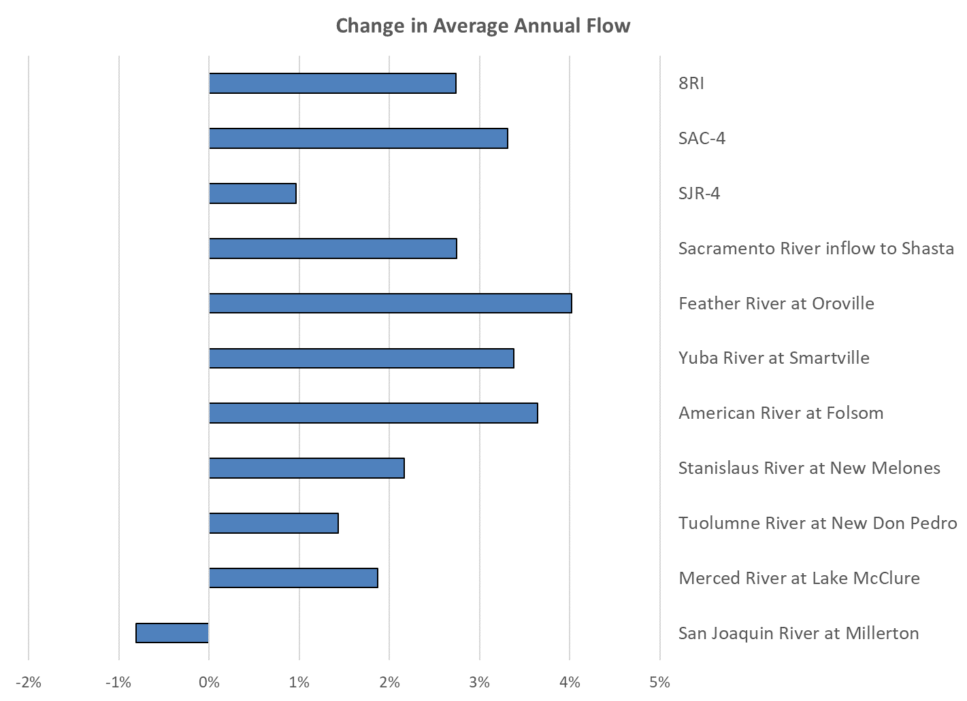
Figure 1. Relative Change in Average Annual Flow

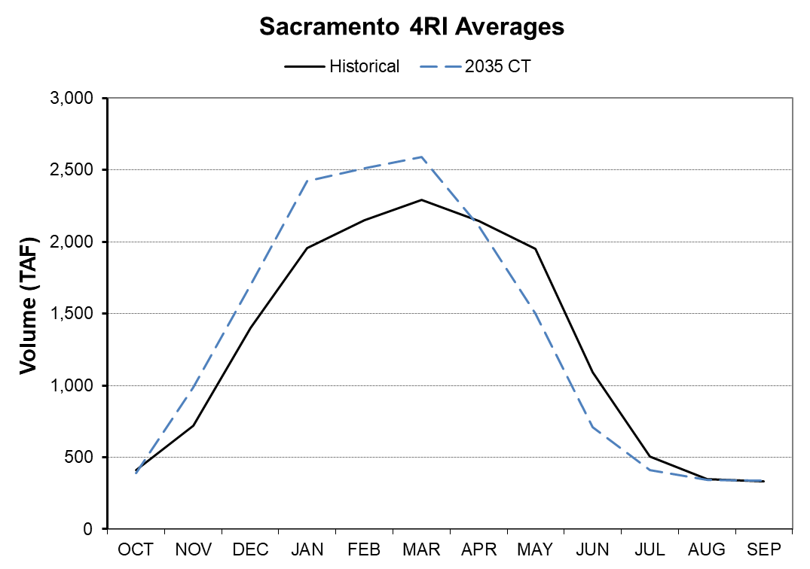
Figure 2. Monthly Pattern of Sacramento Valley Runoff
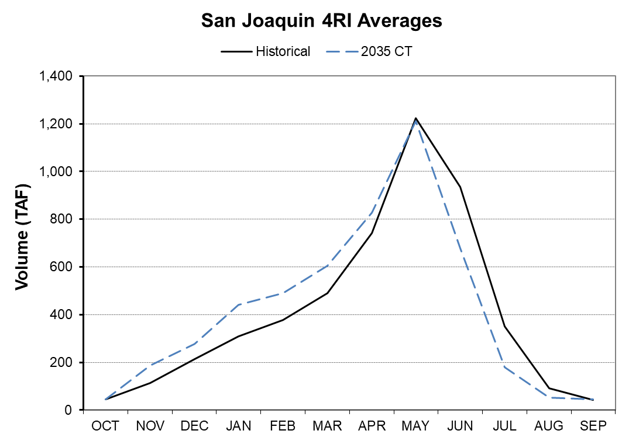
Figure 3. Monthly Pattern of San Joaquin Valley Runoff
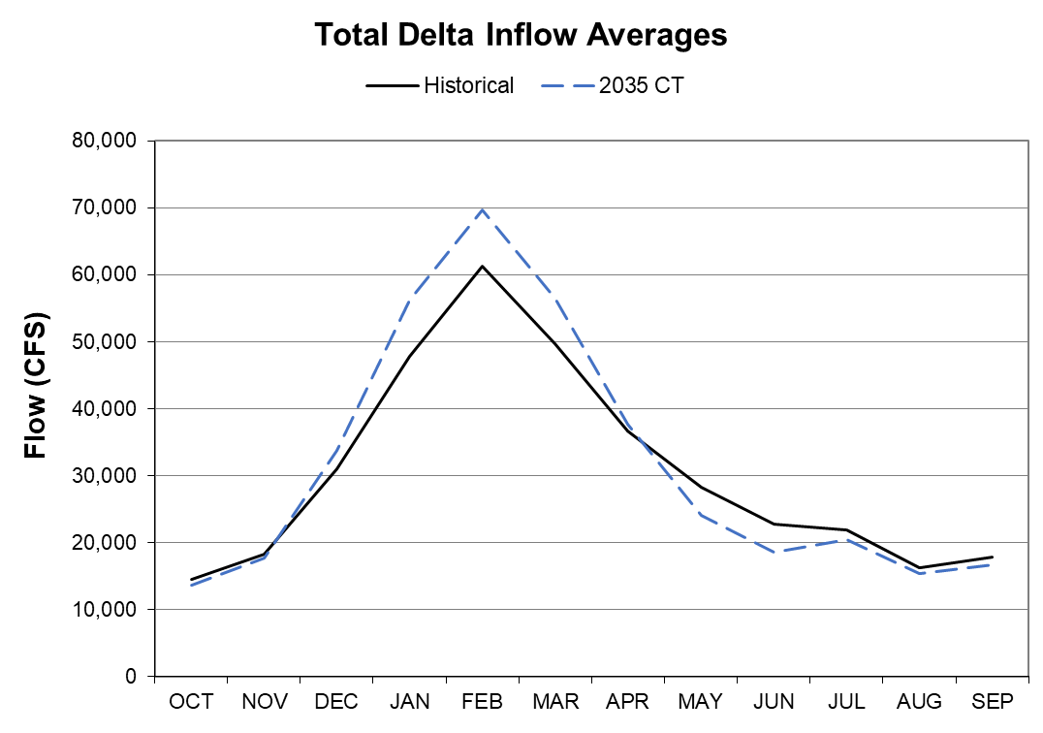
Figure 4. Monthly Pattern of Total Delta Inflow
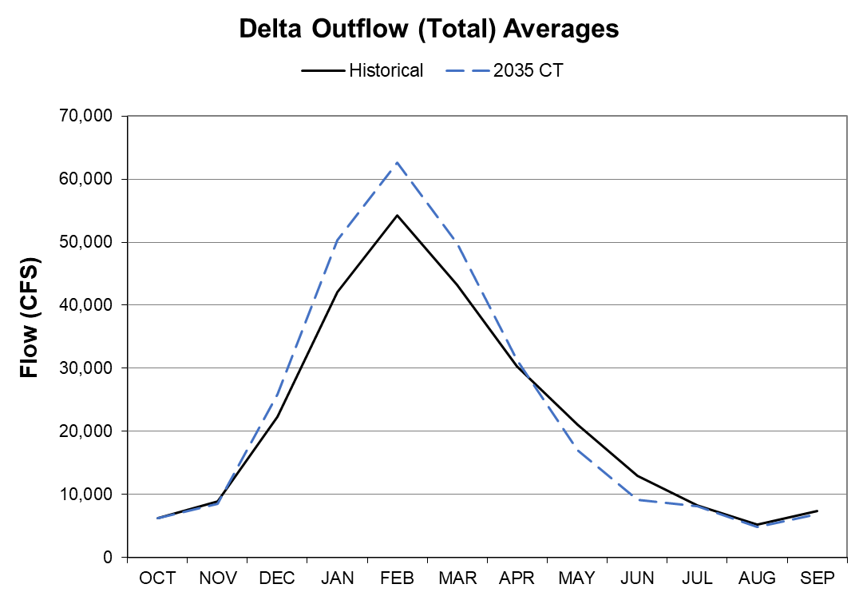
Figure 5. Monthly Pattern of Total Delta Outflow

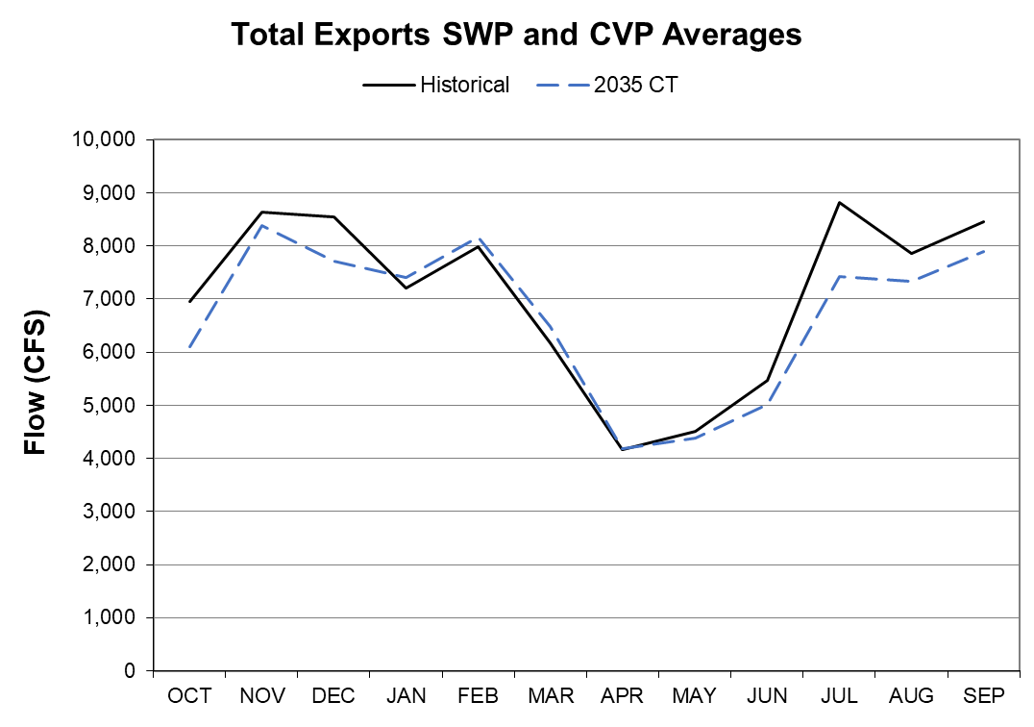
Figure 6. Monthly Pattern of Total Delta Exports

References Cited
California Department of Water Resources Climate Change Technical Advisory Group (DWR CCTAG). 2015. Perspectives and guidance for climate change analysis. California Department of Water Resources Technical Information Record. p. 142.
California Department of Water Resources (DWR). 2018. The Final State Water Project Delivery Capability Report 2017. March 2018.
California Department of Water Resources (DWR). 2019. Final Environmental Impact Report for Long-Term Operation of the California State Water Project. November 2019.
California Ocean Protection Council (OPC) 2018. State of California Sea-Level Rise Guidance: 2018 Update. March 2018.
California Water Commission (CWC). 2016. Water Storage Investment Program: Technical Reference. November 2016.
Daly, C., R.P. Neilson, D.L. Phillips. 1994. “A Statistical-Topographic Model for Mapping Climatological Precipitation over Mountainous Terrain.” Journal of Applied Meteorology. Vol. 33, 140-158.
Intergovernmental Panel on Climate Change (IPCC). 2013. Climate Change 2013: The Physical Science Basis. Contribution of Working Group I to the Fifth Assessment Report of the Intergovernmental Panel on Climate Change. T.F. Stocker, D. Qin, G.-K. Plattner, M. Tignor, S.K. Allen, J. Boschung, A. Nauels, Y. Xia, V. Bex, and P.M. Midgley, eds. Cambridge, United Kingdom and New York, New York: Cambridge University Press. p. 1535.
Liang, X., D.P. Lettenmaier, E.F. Wood, and S.J. Burges. 1994. “A Simple Hydrologically Based Model of Land Surface Water and Energy Fluxes for General Circulation Models.” Journal of Geophysical Research. Vol. 99, 14415–14428.
Liang, X., D.P. Lettenmaier, and E.F. Wood. 1996. Surface Soil Moisture Parameterization of the VIC-2L Model: Evaluation and Modification.
Livneh, B., E. A. Rosenberg, C. Lin, V. Mishra, K. Andreadis, E. P. Maurer, and D.P. Lettenmaier. 2013. “A long-term hydrologically based data set of land surface fluxes and states for the conterminous U.S.: Update and extensions.” Journal of Climate.
Nijssen, B., D.P. Lettenmaier, X. Liang, S. W. Wetzel, and E.F. Wood. 1997. “Streamflow simulation for continental-scale river basins.” Water Resour. Res. 33, 711-724.
Pierce, David W., Daniel R. Cayan, and Bridget L. Thrasher. 2014. “Statistical Downscaling Using Localized Constructed Analogs (LOCA).” J. Hydrometeor. 15, 2558–2585.
Sandhu, N., D. Wilson, R. Finch, and F. Chung. 1999. “Modeling Flow-Salinity Relationships in the Sacramento-San Joaquin Delta Using Artificial Neural Networks.” Technical Information Record OSP-99-1, Sacramento: California Department of Water Resources.
Seneviratne, S., and Wu, S. 2007. “Chapter 3 – Enhanced Development of Flow-Salinity Relationships in the Delta Using Artificial Neural Networks: Incorporating Tidal Influence.” Methodology for Flow and Salinity Estimates in the Sacramento-San Joaquin Delta and Suisun Marsh. 28th Annual Progress Report to the State Water Resources Control Board. Sacramento, CA.
Taylor, Karl E., Ronald J. Stouffer, and Gerald A. Meehl. 2012. An Overview of CMIP5 and the Experiment Design. Bull. Amer. Meteor. Soc. 93, 485–498.
Wilbur, R., and Munévar, A. 2001. “Chapter 7 – Integration of CalSim-II and Artificial Neural Networks Models for Sacramento-San Joaquin Delta Flow-Salinity Relationships.” Methodology for Flow and Salinity Estimates in the Sacramento- San Joaquin Delta and Suisun Marsh. 22nd Annual Progress Report to the State Water Resources Control Board. Sacramento, CA.

