Upper Sacramento River Daily River Flow and Operations Model

Introduction
This document provides the summary of modeling performed to simulate daily flow and operations in the reservoirs, rivers and other conveyance features that are part of the Central Valley Project (CVP) and the Sites Project for the Sites Reservoir Project Revised Draft Environmental Impact Report/Supplemental Draft Environmental Impact Statement (RDEIR/SDEIS). It includes a description of the Upper Sacramento River Daily Operations Model (USRDOM) and results used in the detailed evaluation of alternatives. USRDOM results are used or referenced in:
- Chapter 5 Surface Water Resources
- Chapter 7 Fluvial Geomorphology
USRDOM simulates daily flow and storage conditions in the upper Sacramento River including Trinity basin, Sacramento River from Shasta Lake to Knights Landing and Colusa Basin including the Sites Project conveyance and storage features. The analytical framework used to evaluate the alternatives is summarized in Appendix 1A Introduction to Appendices and Modeling Information. Assumptions used in modeling the alternatives are summarized in Appendix 5A Surface Water Resources Modeling of Alternatives. USRDOM utilizes results from CalSim II to evaluate the impacts of changing diversion, in-basin use and Delta operations under projected conditions within current regulatory and operational regimes. It couples the downstream monthly operational decisions in CalSim II to a simulation of the associated sub-monthly operational response at Shasta Lake depending on the inflows. It is particularly useful in verifying the CalSim II simulated river conditions and the availability of excess flows to fill Sites Reservoir under the capacity and operational constraints of the intakes at Red Bluff and Hamilton City.
Development of USRDOM, calibration and verification, its use in planning simulations and application comparative analysis is documented in detail in the final USRDOM Development, Calibration, and Application report prepared by CH2M HILL for Reclamation (CH2M HILL, 2011).

Objective
USRDOM is used in several ways as part of modeling of the operations of the RDEIR/SDEIS Alternatives. It was used to test and finalize the CalSim II operations for the Alternatives. One main objective of using USRDOM in the RDEIR/SDEIS was to simulate daily flows to inform CalSim II (monthly) about the potential restrictions on the diversions subject to operational constraints. It was also used to evaluate flow conditions on a daily-weekly time scale along the Sacramento River from Keswick Dam to Knights Landing and in the Colusa Basin. The results from USRDOM are used for input into biological and flow regime models to evaluate the alternatives.

Methods

Project Intake Operations Assumptions
The detailed modeling assumptions used for the alternatives modeled for the RDEIR/SDEIS are described in Appendix 5A Surface Water Resources Modeling of Alternatives. This section briefly describes the key operational assumptions used in the USRDOM model for evaluating the alternatives.
The operational assumptions governing the diversions at the two Project intakes, namely existing Tehama Colusa Canal (TC Canal) Intake and Glenn-Colusa Irrigation District Main Canal (GCID Main Canal) Intake include:
- Restrictions based on the available channel conveyance capacities at various locations along the TC Canal and GCID Main Canal. Further, restrictions based on the dedicated annual maintenance periods for TC Canal and GCID Main Canal conveyance systems.
- Restrictions based on meeting the specified bypass flow requirements downstream of each intake. In addition, diversions are restricted based on the seasonal bypass flow requirements specified for the Sacramento River.
- Restrictions based on the occurrence of pulse flows in the Sacramento River, which provide key biological cues for the outmigrating juvenile winter-, spring-, fall, and late fall-run Chinook salmon, as well as a potion of the steelhead juvenile fish. Therefore, diversions are restricted when pulse events are recognized in October through May. Sacramento River flow at Bend Bridge and tributary flow upstream of Bend Bridge (Cow Creek, Cottonwood Creek, and Battle Creek) were used to identify pulse signals as part of the modeling.

Overview of the Planning Analysis
For RDEIR/SDEIS, CalSim II is the model of choice for the lead agencies to simulate reservoir operations and river flow conditions. CalSim II simulates CVP and State Water Project (SWP) operations on a monthly timestep from WY 1922 through WY 2003. Therefore, for the USRDOM projected conditions simulation, the inputs are taken from CalSim II for a consistent analysis. Appendix 5B Water Resources System Modeling includes detailed description of the CalSim II model. Because USRDOM requires inputs on a daily timestep, the monthly inputs and outputs of the CalSim II model are downscaled to a daily timestep using the CAL2DOM utility. CAL2DOM utility translates monthly CalSim II operations data to a daily time step. It uses the inputs and outputs from CalSim II, USRDOM hydrology inputs, and other datasets to compute inflows, diversions, and evaporation rates for using as inputs in the USRDOM.

Operations Modeling with USRDOM
CalSim II was the core model used to simulate Sites Project operations. However, the assumptions related to the intake operations require daily flow data in determining the diversions allowed at the intakes, in turn affecting the system-wide operations. Since CalSim II is a monthly timestep model, USRDOM results were used to enforce the intake operations on a sub-monthly scale for pulse protection, which was developed to protect fish migration during naturally occurring, storm-induced, pulse flow events in the Sacramento River.
Due to the complexity in the intake operational rules, a spreadsheet tool was developed to implement the operational constraints using the daily results from the USRDOM simulation of No Action Alternative. Further, CalSim II and USRDOM were run iteratively to ensure periods of pulse protection were simulated accurately. Figure 5C-1 shows the schematic of the modeling process used to determine periods of pulse protection.
First, a draft CalSim II simulation was run with all the physical, regulatory, and operational assumptions for No Action Alternative. The results from this draft CalSim II simulation were used to run a draft USRDOM simulation for No Action Alternative. The USRDOM setup included assumptions consistent with the draft CalSim II model. Daily flows estimated by USRDOM were then used in a post-processing spreadsheet to determine the days requiring pulse protection. The post-processing spreadsheet generates a timeseries of the number of days that Sites diversions are restricted due to pulse protection in each month of the 82-year period. Next, the draft CalSim II simulation of No Action Alternative is re-run with the new pulse protection timeseries input. Then, CalSim II simulations of Alternatives 1A, 1B, 2, and 3 were run using the same pulse protection inputs. Finally, USRDOM simulations of No Action Alternative and each alternative are run using the corresponding CalSim II outputs. The USRDOM setup between each Alternative and No Action Alternative were consistent. Although pulse protection is not employed in No Action Alternative, the pulse protection input timeseries was included in the CalSim II simulation of No Action Alternative for consistency among all models.
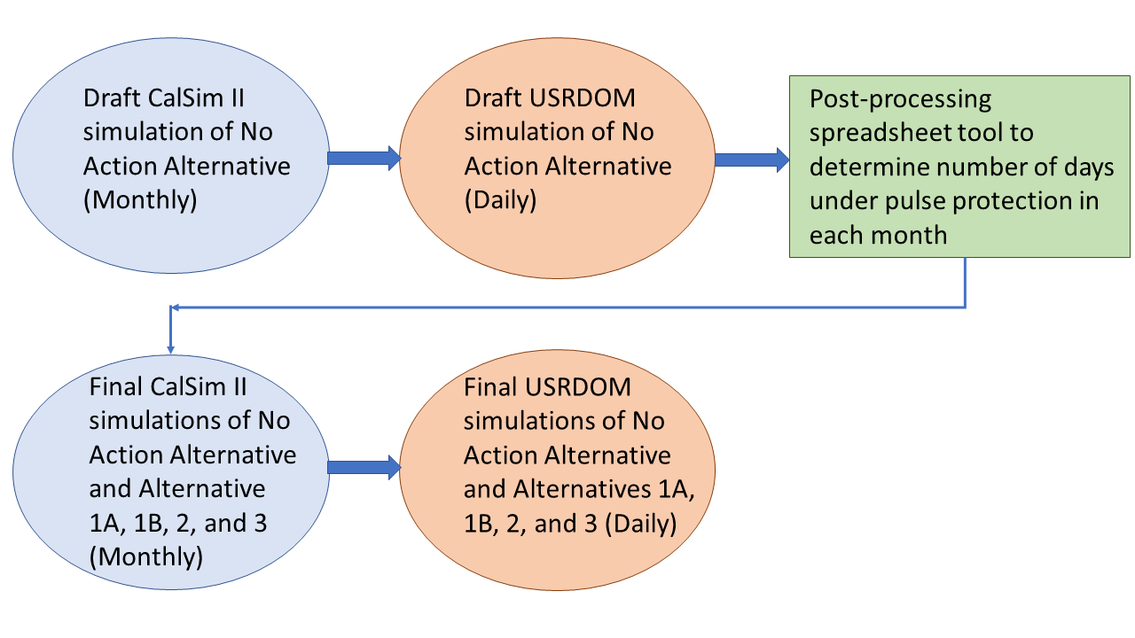
Figure 5C-1. Operations Modeling Process used for Sites Alternatives Evaluation.

Analysis of Alternatives
For the RDEIR/SDEIS, the results from the final USRDOM simulations were used to evaluate the effects of the Alternatives 1A, 1B, 2, and 3 on daily Sacramento River flows at Bend Bridge, below Red Bluff Diversion Dam, and near Wilkins Slough and diversions at Red Bluff and Hamilton City. USRDOM results of weir spills into the Sutter Bypass from Ord Ferry, Moulton Weir, Colusa Weir, and Tisdale Weir are also included in this appendix to asses the effects Sites operations.

Limitations
The following limitation should be considered in using USRDOM results:
In the downscaling of CalSim II boundary condition flows for use in the USRDOM simulations, diversions at Red Bluff and Hamilton City are smoothed from monthly to daily timesteps. In this smoothing operation, in order to conserve volume and have a gradual change in diversion flows (as opposed to sharp changes at monthly or other time scale boundaries), there are some days in which diversions are represented in the model at flow rates that may exceed the sustainable rate of the physical capacity of these facilities. It is recommended that any assessment of flows or other parameters linked to the peak flow rate of these diversions use monthly average values rather than daily or other sub-monthly average values.
The CalSim II model is used to establish system operational conditions and USRDOM is used to interpret these on a daily time-step; all residuals and inconsistencies between the CalSim II and USRDOM models accumulate in storage facilities modeled, including Sites Reservoir; the Sites Reservoir storage in the USRDOM sometimes exceeds physical capacity slightly due to this inconsistency between the models.

Results
The tables and figures in this section show monthly average USRDOM results for river flows, diversions, and weir spills at key locations for the following alternatives:
- No Action Alternative 011221
- Alternative 1A 011221
- Alternative 1B 011221
- Alternative 2 011221
- Alternative 3 020121
The locations and parameters for the results included in this appendix are shown in Table 5C-1.
Table 5C-1. USRDOM Monthly Reports.
Section | Output Parameter | Table Numbers | Figure Numbers
Sacramento | Sacramento River Flow at Bend Bridge | 5C-1-1 to 5C-1-4 | 5C-1-1 to 5C-1-18
Sacramento | Sacramento River Flow below Red Bluff Diversion Dam | 5C-2-1 to 5C-2-4 | 5C-2-1 to 5C-2-18
Sacramento | Red Bluff Diversion - Tehama Colusa Canal | 5C-3-1 to 5C-3-4 | 5C-3-1 to 5C-3-18
Sacramento | Hamilton City Diversion - Glenn Colusa Canal | 5C-4-1 to 5C-4-4 | 5C-4-1 to 5C-4-18
Sutter Bypass | Ord Ferry Spill | 5C-5-1 to 5C-5-4 | 5C-5-1 to 5C-5-18
Sutter Bypass | Moulton Weir Spill | 5C-6-1 to 5C-6-4 | 5C-6-1 to 5C-6-18
Sutter Bypass | Colusa Weir Spill | 5C-7-1 to 5C-7-4 | 5C-7-1 to 5C-7-18
Sutter Bypass | Tisdale Weir Spill | 5C-8-1 to 5C-8-4 | 5C-8-1 to 5C-8-18
Sacramento | Sacramento River Flow at Wilkins Slough | 5C-9-1 to 5C-9-4 | 5C-9-1 to 5C-9-18

Report formats
- Exceedance tables comparing an alternative against the No Action alternative (exceedance values, long-term average, and average by water year type
- Monthly pattern charts (long-term average and average by water year type) including all alternatives
- Monthly exceedance charts (all months) including all alternatives

References Cited
CH2M HILL. 2011. USRDOM Development, Calibration, and Application. Final. Sacramento, CA. Prepared for Bureau of Reclamation, Mid Pacific Region, CA.

